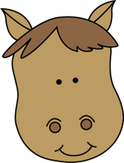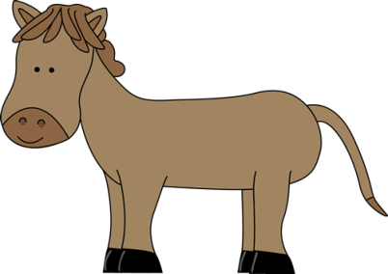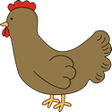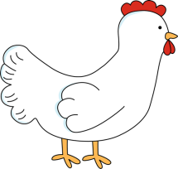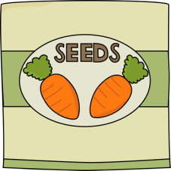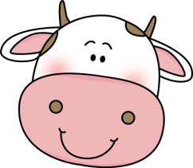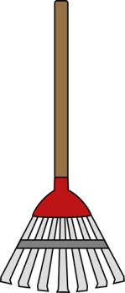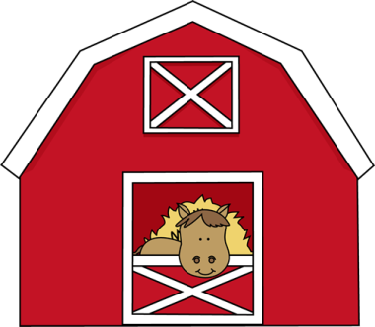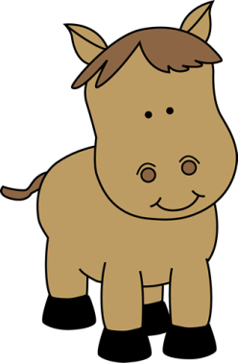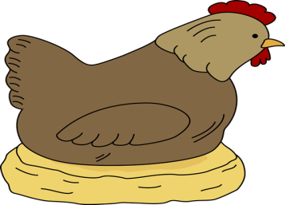

1. The adult male of a hen.

2. Where a farmer and his family live.

3. The seeds of plants that are used for food.

4. An open area of land without trees and buildings.

5. A plant product that is grown by farmers.

6. Usually a flat area of land covered with tall grass.

7. A measure of land area used in the US and GB.

8. Grass that has been cut and dried.

9. An open container with a handle that is used to hold and carry water.

10. The season when crops are gathered from the fields.

11. See illustration.

12. A tower that is used to store food (i.e. grain).

13. Male cows.

14. A large pile of hay.

15. See illustration.

16. A female sheep.

17. See illustration.

18. A baby pig.

19. Meat from a bird.

20. See illustration.

21. A farm vehicle with two big wheels and two small wheels.

22. Cows, bulls, steers etc.

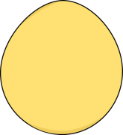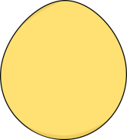

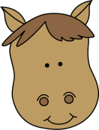

S

G

G

C

A

T

T

E

R

O

T

C

A

R

T

E

K

A

Y

R

T

L

U

O

P

I

G

T

L

B

N

R

E

W

E

S

R

H

K

C

A

T

S

Y

H

N

X

O

L

I

H

A

R

T

V

ST

T

E

K

C

U

B

Y

H

E

R

A

M

E

A

D

W

P

O

R

D

L

E

I

N

I

A

G

E

S

U

O

H

M

R

A

F

K

C

O

C

1. The adult male of a hen.

2. Where a farmer and his family live.

3. The seeds of plants that are used for food.

4. An open area of land without trees and buildings.

5. A plant product that is grown by farmers.

6. Usually a flat area of land covered with tall grass.

7. A measure of land area used in the US and GB.

8. Grass that has been cut and dried.

9. An open container with a handle that is used to hold and carry water.

10. The season when crops are gathered from the fields.

11. See illustration.

12. A tower that is used to store food (i.e. grain).

13. Male cows.

14. A large pile of hay.

15. See illustration.

16. A female sheep.

17. See illustration.

18. A baby pig.

19. Meat from a bird.

20. See illustration.

21. A farm vehicle with two big wheels and two small wheels.

22. Cows, bulls, steers etc.