NUMBERS

BODY

SHAPES

COLORS



1. square
2. star
3. circle
4. orange
5. purple
6. yellow
7. tree
8. three
9. free
10. legs
11. lips
12. mouth
13. ear
14. hair
15. eye
16. rectangle
17. circle
18. triangle
19. grey
20. green
21. blue
22. three
23. thirteen
24. thirty

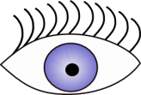

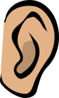

1. eye
2. eye
3. head
4. star
5. heart
6. square
7. blue
8. red
9. purple
10. thirteen
11. three
12. thirty

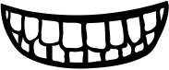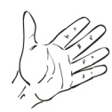

1. feet
2. mouth
3. teeth
4. foot
5. finger
6. hand
7. heart
8. star
9. square

1. rectangle
2. square
3. star
4. white
5. black
6. grey
7. yellow
8. red
9. orange
10. forty-nine
11. ninety-four
12. four-nine
13. fifty
14. fifty-five
15. fifteen