ANIMALS

CLOTHES

FRUITS

FOODS

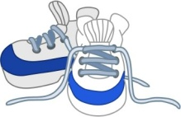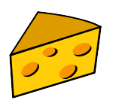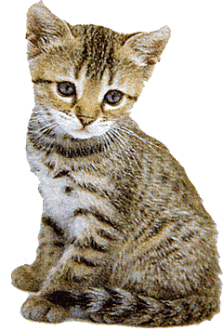

1. lemonade
2. lemon
3. lime
4. butter
5. cheese
6. meat
7. hat
8. bat
9. cat
10. snickers
11. sneakers
12. sandals

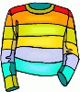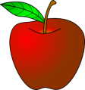

1. T-shirt
2. hoodie
3. sweater
4. plum
5. peach
6. apple
7. bun
8. loaf of bread
9. roll
10. pick
11. pig
12. big

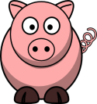

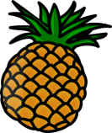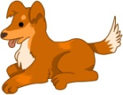

1. cap
2. hat
3. bat
4. apple
5. peach
6. pinapple
7. scrambled egg
8. boiled egg
9. fried egg
10. dog
11. duck
12. doll

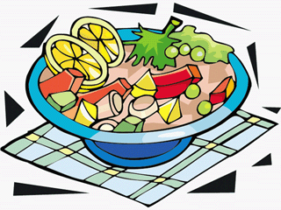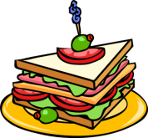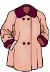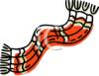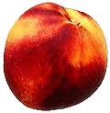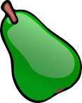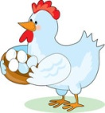

1. jacket
2. raincoat
3. coat
4. scarf
5. belt
6. tie
7. grape
8. peach
9. melon

1. pear
2. plum
3. raisin
4. salad
5. lettuce
6. soup
7. burger
8. sandwich
9. toast
10. cock
11. hen
12. chicken
13. donkey
14. pony
15. horse