- Fill in the blanks with the appropriate one of “ ever” or “ never” .
A: Have you ________ seen a ghost?
B: No, I have _________ seen a ghost.
- 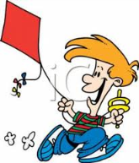
A: Have you _______ flown a kite ?
B: No, I have _______ flown a kite.
- 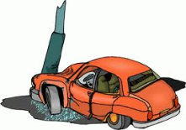
I have _______ had such a bad accident.
A: Have you _______ eaten Sushi?
B: Yes, I have.
- 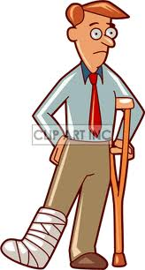
My father has _______ broken his leg.
Mert has _______ travelled by a plane.
A: Has Emir ________ had a nightmare?
B: Yes,he has.
- 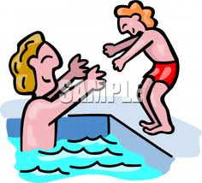
A: Have you _________ swum in a pool ?
B: Yes, I have .
- 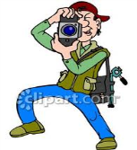
Murat has __________ taken photos of touristic places.
- 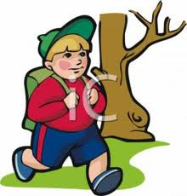
A : Have you _________ gone hiking?
B : No, I have _________ gone hiking.
- 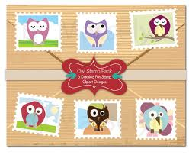
A : Have you __________ collected stamps?
B : Yes, I have.
- 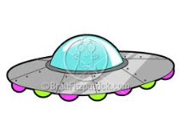
A: Have you ___________ seen a UFO ?
B : No, I have ___________ seen a UFO.
- 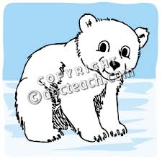
A: Have you ___________ seen a polar bear?
B: No, we have ___________ seen a polar bear.

- Fill in the blanks with “ me too” or “ me “neither” .

- I’ve been to Africa.

- I have flown to Germany.
- I haven’t eaten spaghetti.
- I ‘ve never seen a Scottish man with a kilt.

- I ‘ve never seen Turkey.

- I’ve visited the Louvre Museum.

- Circle the correct option.
Tessa : Trevor. I ‘ ve just / already talked to dad and he’s told me that you haven’t finished your assignments. Have you finished your homework already /yet ?
Trevor : Yes,I have just / already finished it. Are you going to make dinner ?
Tessa : No, I have just / already made it. It is in the oven. Would you like something to eat ?
Trevor : No thanks, I’ve just / already eaten a hamburger. Have you finished washing the dishes just / yet ?
Tessa : No,I haven’t . Have you tidied your room already / yet ?
Trevor : No, not . I’ll do it in a minute. What about you?
Tessa : I have already /just tidied mine.

- a) Think about the expressions written dark.

- I have been interested in psychology since the beginning of our conversation.
- I have been interested in science since I started primary school.
- You have been interested in psychology for the last ten minutes.

b) Choose the correct one .
1. Do the expressions in 1. and 2. sentences
show for the _________ of an action.
- starting b) the length of time
2. Does the expression in 3. Sentence show for the _________ of an action.
a) starting b) the length of time

For + the length of time for an action | Since + the starting time of an action
For hours  three weeks  six months  ten years  many years  a short time | Since four o’clock  15 July  May 1960  I was a child  I saw you last

- Mark the corrcert answer.

- Lisa has been a professional singer _________ 1980.

- since b) for

- So far, It has rained _________ five hours.

- since b) for

- I haven’t been to snowboarding ________ last winter.

- since b) for

- Joe has been a student here ________ March.

- since b) for

- The scientist have studied on this project ________ six months.

- since b) for

- My sister and I have studied Maths ________ 10 o’clock.

- since b) for

- Mary has been upset ________ she started crying.

- since b) for

- The astronouts have been in the outer space ________ last month.

- since b) for

- Two countries have had good relations ________ 19th century.

- since b) for

- Larry has worked in this office ________ five years.

- since b) for

- Write True ( T ) or False ( F) .

- I really missed my father. I haven’t seen him for January. ______

- The politicians have had many discussions since February. ______

- I haven’t seen him since I left the office. ______

- Jenny has called me twice for Tuesday. _______

- I have waited here for 25 minutes. _______

- The teacher has taught the same unit for three weeks. ______

- The coordinator has worked on the project for September. ______

- People have had fights since the beginning of the time. ______

- Kate has been ill for four days. _____

- We haven’t called each other for a long time . ______

