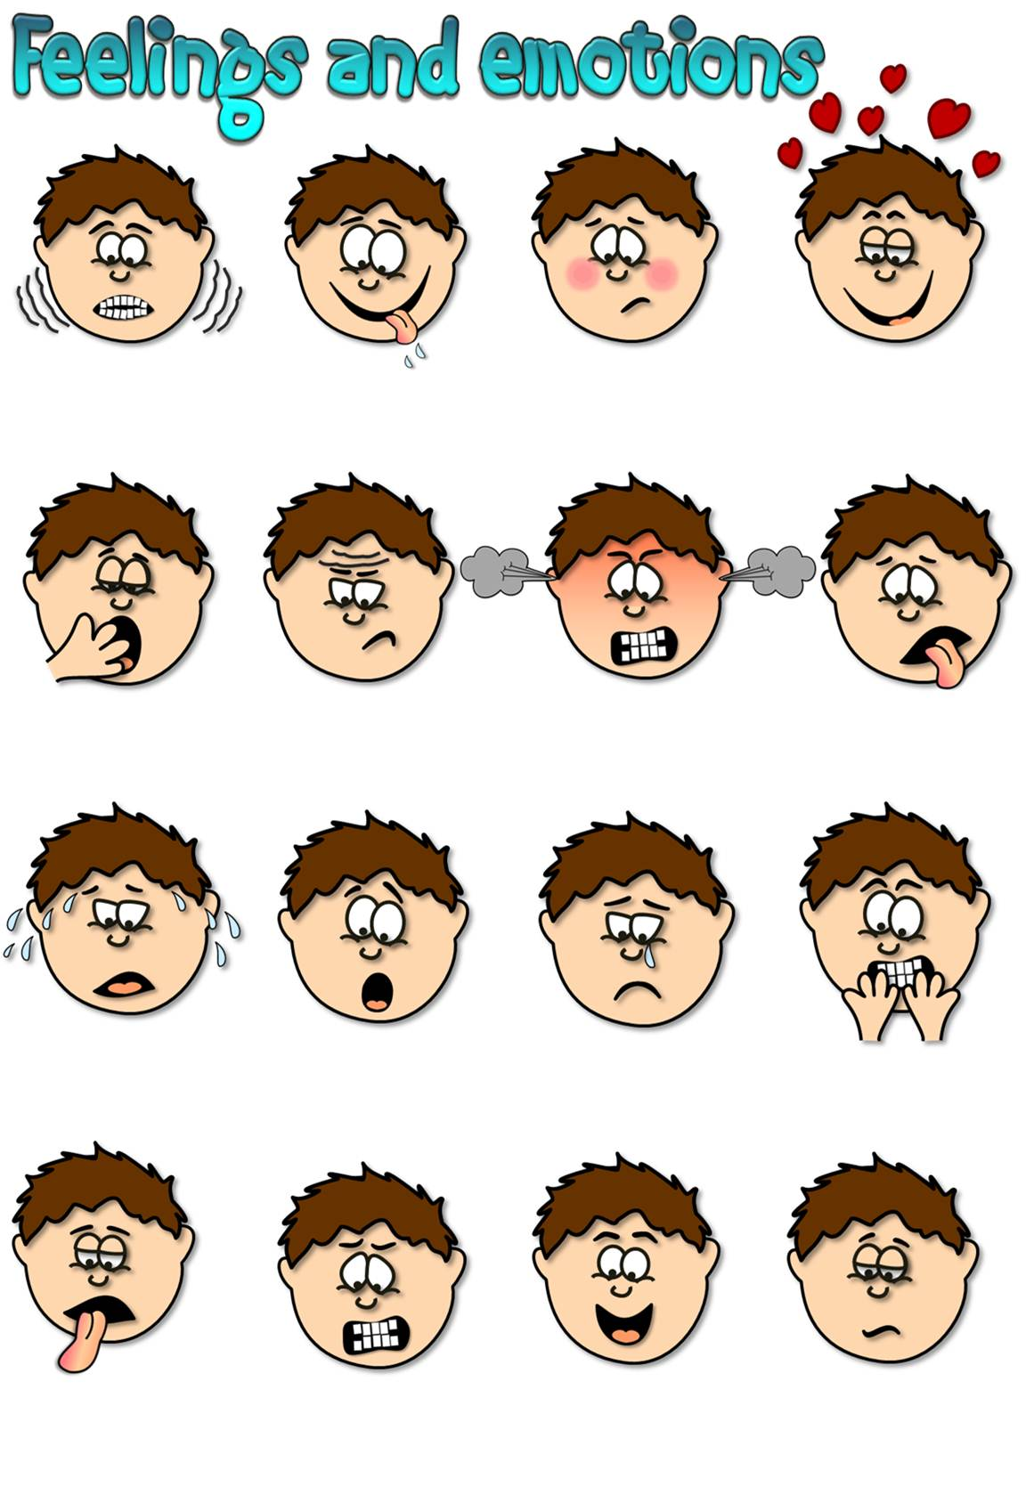
a) hot
b) excited
c) cold
a) shy
b) hungry
c) surprised
a) happy
b) shy
c) angry
a) in love
b) sad
c) shocked
a) frightened
b) sleepy
c) lonely
a) disgusted
b) bossy
c) satisfied
a) merry
b) cheerful
c) furious
a) frustrated
b) patient
c) glad
a) brave
b) bored
c) hot
a) scared
b) joyful
c) lonely
a) sad
b) optimistic
c) relaxed
a) comfortable
b) surprised
c) jealous
a) shocked
b) worried
c) exhausted
a) excited
b) comfortable
c) bored
a) happy
b) jealous
c) envious
a) proud
b) angry
c) amazed

a) hot
b) excited
c) cold
a) shy
b) hungry
c) surprised
a) happy
b) shy
c) angry
a) in love
b) sad
c) shocked
a) frightened
b) sleepy
c) lonely
a) disgusted
b) bossy
c) satisfied
a) merry
b) cheerful
c) furious
a) frustrated
b) patient
c) glad
a) brave
b) bored
c) hot
a) scared
b) joyful
c) lonely
a) sad
b) optimistic
c) relaxed
a) comfortable
b) surprised
c) jealous
a) shocked
b) worried
c) exhausted
a) excited
b) comfortable
c) bored
a) happy
b) jealous
c) envious
a) proud
b) angry
c) amazed







happy
surprised
bored
frustrated
scared
hungry

