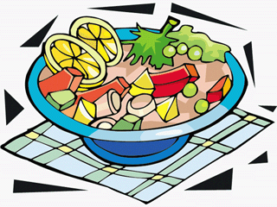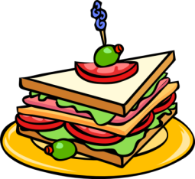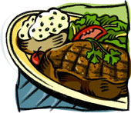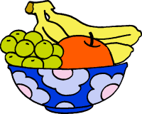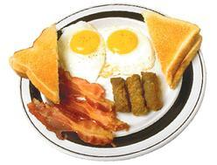11954264641928060240Machovka_Eye_svg_med.png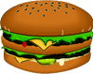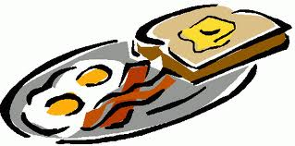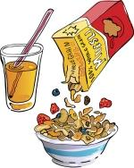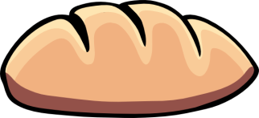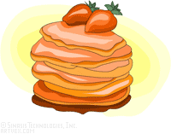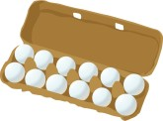

I am a yellow vegetable, I can come in many forms: on the cob or as kernels in a can.

Which fruit is ripe when it is red, with a cap of green, and it’s often said to go well with cream?

What do you call a mixture of raisin, nuts and M&M’s?

What is a jiggly, wiggly red stuff from the fridge that a lot of kids love?

What am I going to eat? I see…carrots, lettuce, cucumber, tomatoes, pepper, corn, pasta and dressing.

Name three cold drinks!

Don’t spill the beans! But you get an extra throw!

What is the red tomato sauce called you eat with your fries?

Flat circles on the stove and some syrup – mmmm what am I going to eat?

Two slices of bread, a banana, and some peanut butter.

Onion is a vegetable. True or False?

What do you get to eat at a birthday party?

A big, fluffly sugary thing on a stick –it appeals most to kids.

How can you prepare eggs?

(Name three ways).

Go back to start!

I am more of a dessert. I come in many flavours..vanilla, strawberry…

Name three fast food restaurants!

I am kind of a candy. I come in milk, dark or white.

Name three hot drinks!

What do you eat for breakfast?

How many pieces of fruit and vegetables are you supposed to eat every day?