**MATERIEL SCOLAIRE**

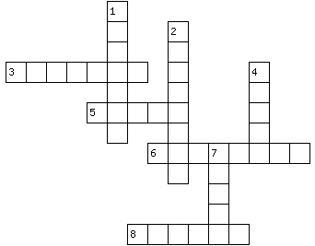

**1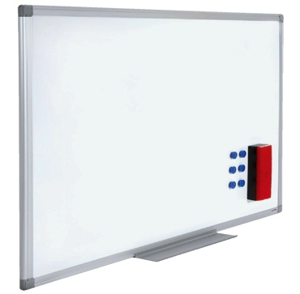 2 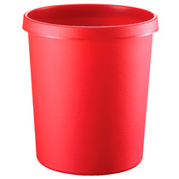 7 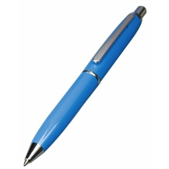 4**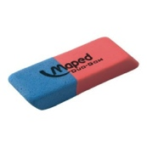

**______________________ ______________________ ______________________ ______________________**

**3 5 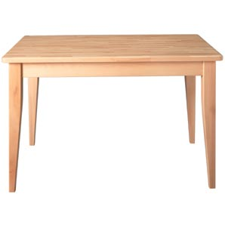 6 8**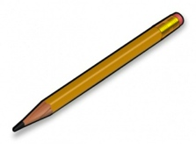

**______________________ ______________________ ______________________ ______________________**

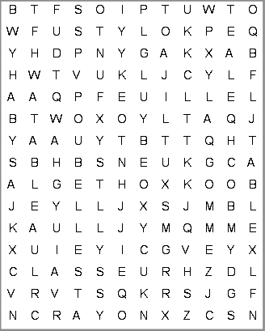

**   **

**Le ___________________ . La ___________________. Le ___________________ . La ___________________.**

**   **

**La ___________________ . La ___________________. Le ___________________ . Le ___________________.**