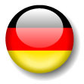

1. (Anni / ) – Hi my name is ____ and I am from ___________. I speak __________________________.
2. (Pierre / 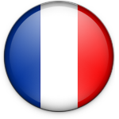) –Hello, my name is ________ and I am from __________. I speak ___________.
3. (Pedro /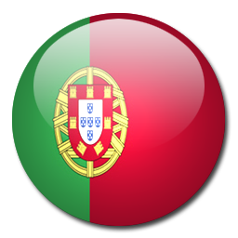) –Hey there, I’m ________ and I am from _____________. I speak _____________________________.
4. (Matti / 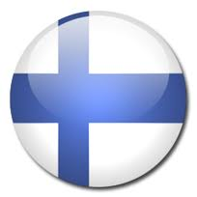) – Hi, I’m Matti. I am from _____________. We speak _______________________.
5. (

5. (Liesbet / 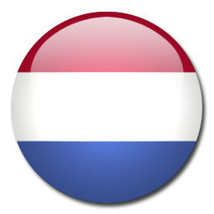) Hi, I’m ____________. My home country is _____________. I speak ____________.

6. (Olav / 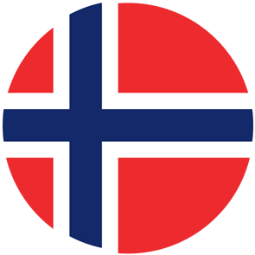) - ________ is my name. I am from ____________ and we speak ________________________ .

7. Mena / 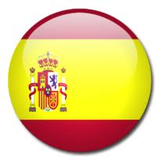) –Hey, I’m _________ and I come from ____________. Here we speak ________________________ .

8. (Yvonne / ) Hello, _________ here. I am from Vancouver in ____________ and in this part of Canada we speak ________________ .

9. (Andreas / 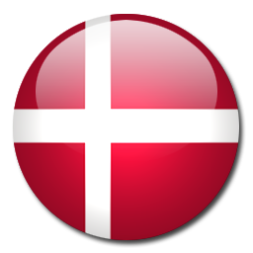) Hej! It is ________ and means “Hi”. I am from _______________ and speak ________.

Country: Canada Denmark England Finland France Germany

Nationality: Canadian Danish English Finnish French German

Language: English/ Danish English Finnish French German

Country: Holland Italy Norway Poland Portugal Spain

Nationality: Dutch Italian Norwegian Polish Portuguese Spanish

Language: Dutch Italian Norwegian Polish Portuguese Spanish

Oh, hi! I am Oscar. I’m from Italy. I speak Italian.

Hi, I am Kelly. I’m from the USA. I speak (American) English.