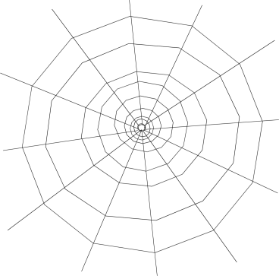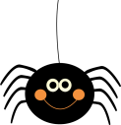

**4**

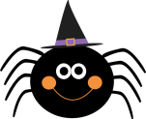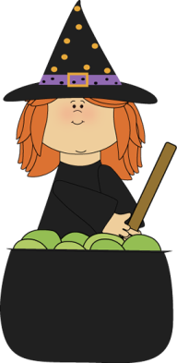

**11**

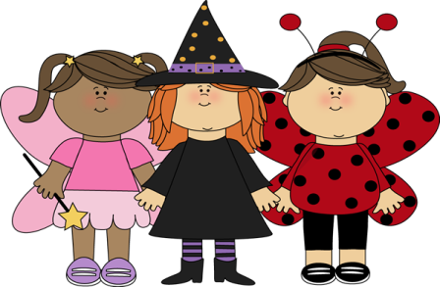

**1**

**2**

**3**

**19**

C:\Users\user\AppData\Local\Microsoft\Windows\Temporary Internet Files\Content.IE5\7NL5AKM4\MC900349121[1].wmf

**15**

**CAULDRON**

**DEVIL**

**EYEBALLS**

**GHOST**

**GRAVEYARD**

**HAUNTED HOUSE**

**JACK O’LANTERN**

**MUMMY**

**FRIGHTEN**

**NIGHTMARE**

**4**

**18**

**5**

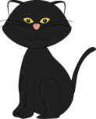

**6**

**OWL**

**PUMPKIN**

**SKELETON**

**SKULL**

**SPIDER**

**SPOOKY**

**TRICK OR TREAT**

**VAMPIRE**

**WITCH**

**12**

C:\Users\user\AppData\Local\Microsoft\Windows\Temporary Internet Files\Content.IE5\7NL5AKM4\MC900053352[1].wmf

7

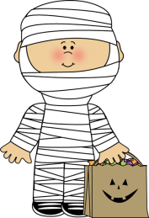

**5**

**8**

**9**



**13**

**10**

C:\Users\user\Dropbox\Dropbox\MyCuteGraphics\Halloween\creepy-eyeballs.png

**3**

**2**

**11**

**12**



**8**

**7**

**13**



**14**

C:\Users\user\AppData\Local\Microsoft\Windows\Temporary Internet Files\Content.IE5\WHW9BQL5\MC900238395[2].wmf

**15**



**6**

C:\Users\user\AppData\Local\Microsoft\Windows\Temporary Internet Files\Content.IE5\WHW9BQL5\MC900304949[1].wmfC:\Users\user\Dropbox\Dropbox\MyCuteGraphics\Halloween\purple-halloween-bat.png

**9**

**16**

**100**

**17**

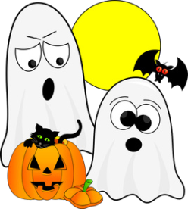

**18**

**17**

**What’s the secret message?**

**19**