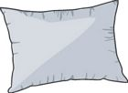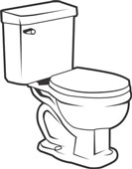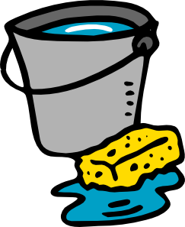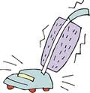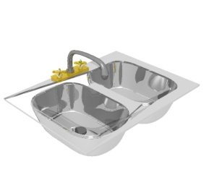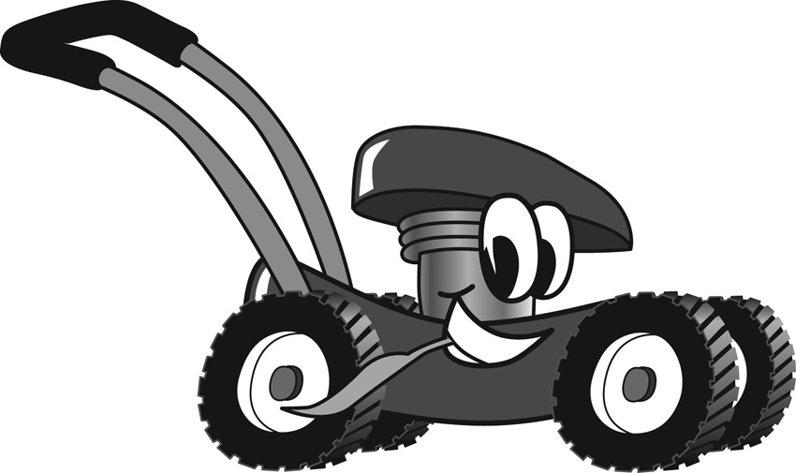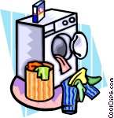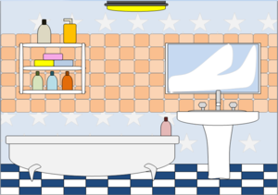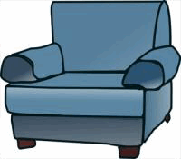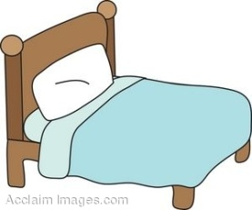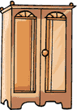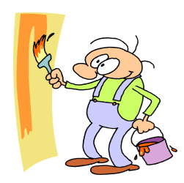

What do you use a broom for?

Which room would you go to to watch television?

How many rooms has your house or flat got?

Mention four things from YOUR room!

What do you call the machine that do the dishes?

Name four electrical appliances.

What do you call the furniture that sits more people?

Mention three things you use in the bathroom!

Switch places!

What am I?

You are exhausted and need a rest. Miss a turn!

What do you call the room where you enter a house?

Is basement and cellar the same?

Name find things you put in the fridge?

Mention three types of housing.

Phew!

What is the room called where your parents sleep?

What two things can you brush?

Which room do you go to if you want to have a shower?

Mention four things that make up a house!

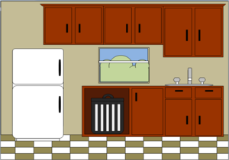

What is this?

Mention three things that can grow in the garden.