**2014-2015 SCHOOL YEAR**

**FATIN RUSTU ZORLU PRIMARY SCHOOL FIRST TERM- 1st EXAM FOR 5TH GRADES**

**Name :**

**Surname:**

**Number:**

**Class :**

**1)Write the numbers in English. ( Sayıları İngilizce olarak yazın ) (3*7p)**

**a) 20-………………………………. e) 7-………………………………..**

**b) 35-………………………………. f)1-…………………………………**

**c) 5-………………………………. g) 10-……………………………….**

**d) 60-……………………………….**

**2) Write the time.’’What time is it?’’ (saatleri yazınız. ‘’Saat kaç?’’) (5*5p)**

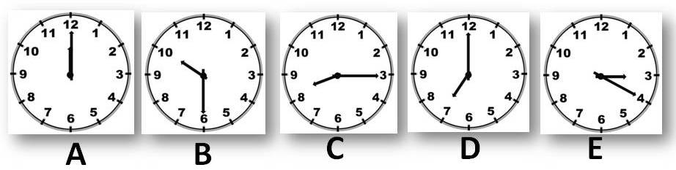

**A:………………………………………………..**

**B:…………………………………………………**

**C:…………………………………………………**

**D:……………………………………………….**

**E:………………………………………………….**

**3)Write the meanings of the words ( Kelimelerin Türkçe anlamlarını yazın) (2*6p)**

**a) Stand up : ……………………… d)Get up : ………………………**

**b) clean : ……………………… e) Go : ………………………**

**c) close the window ! : ……………………… f) like : ……………………**

**4)Fill in the blanks at the simple present tense form ( Boşlukları geniş zaman (do-does ) formunda doldurunuz.) (3*10p)**

1. She (read)………….books every day.
2. They (come )……………..to school  by minibus .
3. I (like)……………….to  sit at the seaside in Alanya.
4. We always (do) …………..the exercises very carefully.
5. Elif never (cook) ……………meals to us at home.
6. Valat and Ferhat  (drive) ……………..very fast at school campus.
7. We (watch) ………….. films on tv every day.
8. Furkan ( play) ……………computer games .
9. Baran   (go) …………….to bed  at 9 every night.
10. Enes (play)…………..the  piano.

**5)Find the 4 english words. (4 ingilizce kelime bulunuz) (3*4p)**

***1)……………………….. 2)……………………. 3)……………………. 4)………………………..***

|  |  |  |  |  |  |  |  |  |
| --- | --- | --- | --- | --- | --- | --- | --- | --- |
| A | A | G | H | M | K | O | K | S |
| L | O | V | E | O | K | L | N | C |
| G | K | E | G | R | L | E | B | H |
| J | A | Q | Z | N | E | L | N | O |
| W | E | T | T | İ | M | E | A | O |
| D | O | O | R | N | O | V | T | L |
| E | G | Y | J | G | O | E | N | A |
| C | L | O | C | K | N | N | C | A |

***[](http://images.google.com.tr/imgres?imgurl=http://skinner.79bmedia.com/skinner650/Smiley-1.png&imgrefurl=http://skinner.79bmedia.com/skinner650/splashes.html&h=320&w=320&sz=89&tbnid=FDwVPyS8B28h0M:&tbnh=113&tbnw=113&hl=tr&start=1&prev=/images?q=SM%C4%B0LEY&svnum=50&hl=tr&lr=)***