1.Hüseyin: What’s your favorite snack, Mustafa?
Mustafa: My favorite snack is lasagna.
Hüseyin :…………………………………..?
Mustafa: Pasta, cheese, eggs…
- How do you make it?
- How often do you cook it?
- What’s the process?
- What’s in it?
2. Colcannon is a traditional Irish dish. It …………………of mashed potatoes and cabbage with milk, butter, salt and pepper
A) cooks
B) consists
C) serves
D) eats,
3. Diyalog tamamlandığında hangi şık boşta kalır.
Elif : Hello, Elif speaking.
Elsu : Hello, could I speak to Mrs. Adams, please?
Elif : ________________________ at the moment. ________________________ leave a message?
Elsu : _____________________________ her to call me, please? My number is 434 567 89.
- Could you ask…
- Would you like to …
- She is not available…
- Is Mrs. Adams in?
4. Nimet: How often do you check your email?
İrem: What do you mean?
Nimet: …………………………………………….
- I mean, do you check your email a lot?
- I mean, do you have a wireless modem or cable modem?
- I mean, do you spend much time online?
- I mean, is there a connection sing on the screen?

5. Görselin tanımı hangi seçenekte doğru verilmiştir?
A) a computer program to read information on the Internet.
B) a computer program to find information on the Internet.
C) a computer file that you send together with an email message.
D) Internet services you use by entering a username and password.
6. Who accepts the invitation?
Hello, Kemal and I are going to meet at Café Z at 5 p.m. this afternoon. Would you like to join us?
Beyza: Why not? What time are you going to go there?
Bersu: I’d like to, but I can’t. My uncle is going to visit us today.
Gizem: I’d love to but I have an exam tomorrow.
Harun: Thanks but I have to clean my room.
- Harun
- Bersu
- Beyza
- Gizem
7 . Hangi sorunun cevabı parçada yoktur?
The Blue Mosque in İstanbul is the world’s most amazing Mosque. It’s an architecture miracle! The Ottoman Emperor Ahmet the First ordered it and architect Mehmet Ağa designed it. Its construction began in 1609 and took 7 years.
A)What’s the other name of the Blue Mosque?
B) Who designed the Blue Mosque?
C) How long did its construction take?
D) Where is the Blue Mosque?

8. Parçada hangi sorunun cevabı bulunmamaktadır?
The Great Pyramid was the tallest historical man-made structure in the world for over 3,800 years. It is 146.5 meters. Egyptian workers built it as a tomb for Egyptian Pharaoh Khufu, and they constructed it over a 20-year period.
- How tall is the Great Pyramid?
- Why did Egyptian workers build it?
- Who built the Great Pyramid?
- How did they build it?
9. Ali: What is your favorite sport?
Mehmet: It is in-line Skating.
Ali: Where did you learn to play it?
Mehmet: ………………………………………
- I was with my cousine Ayşe.
- I learned it five years ago.
- I learned it in Manavgat.
- It was amazing.

10. Bahsedilen yapıları seçenekteki görseller ile eşleştirdiğimizde hangi seçenek fazladır?
#.Himeji Castle is in Japan. It’s one of the finest example of Japanese architecture.
#.Sumela Monastery is on the Zigana Mountains in Trabzon, Turkey. Local people also name the monastery as “Meryem Ana” or “Virgin Mary”.
#. Burj Dubai is a skyscraper in United Arab Emirates and is the tallest man-made structure in the world. It is 829,8 meters tall.
- 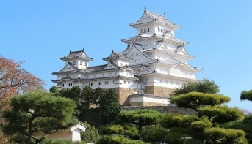

B) 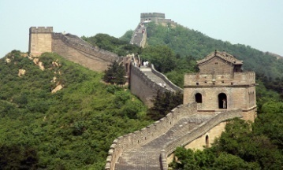

- 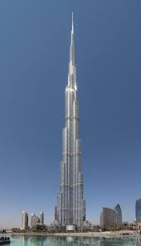

- 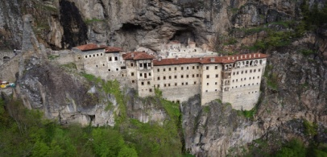

11. Hangi seçenek bir sınıf kuralıdır?
A) Take off your shoes when entering
B) Be nice to your siblings.
C) Don’t jump on the couches.
D) Be kind to your friends.
12) My father is responsible for……………… because he works as a gardener.
A) washing the dishes
B) doing shopping
C) watering the flowers
D) cooking the meals
13. Atik: What’s your favorite sport, Sinan?
Sinan: My favorite sport is Parkour Running.
Atik: Do you need any special equipment to do it?
Sinan: Yes. I need……………………
- some rope
- a pair of trainers
- a parachute
- an axe

14. Büşra: ………………………………………
Jale: For about two weeks.
- When did you go there?
- What did you do there?
- How long did you stay there?
- What did you like the most about it?

15. I’m responsible for…………………………
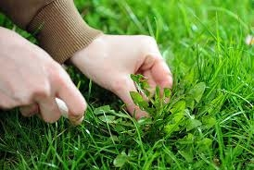
- watering the flowers
- dusting the shelves
- sweeping the leaves
- weeding the garden

16. Tabloda hagi iki seçenek yer değiştirirse tablo doğru olur.
House rules | Classroom rules
a. Don’t eat in the bedrooms; only in the kitchen | 1. Keep your desk tidy and neat.
b. Wash your hands before the meals | 2. Be nice to your siblings
c. Don’t jump on the couches | 3. Raise your hands to speak.
d. Use your quiet voice | 4. Follow the directions
- a-4
- c-2
- d-2
- b-1

17. Nilsu: What do you think about sky diving?
Ezgi: I hate it because to me, it is ……………
- unbearable
- crayz
- fantastic
- incredible

18. Emre: What type of vacation do you prefer? A vacation in the city, at the beach or in the mountains?
Aleh: I prefer a vacation in the city.
Emre: Why do you prefer it?
Aleh: Because it’s more …………………..
- crayz
- boring
- historic
- convenient
19. Hüseyin: Why was Tarsus an important place in history?
Harun: ……………………………………………………………..
- Because it is an important place now.
- Because of its cousine.
- It is in the South central of Turkey.
- Because it was focal point of many civilizations.

20. Sude: Where did you go on your last summer holiday?
Atilla: I went to Bursa.
Sude: ………………………………………………
Atilla: It was warm and sunny.
- Was it amazing?
- How was the weather?
- Where did you visit?
- What did you do there?

