1. Verilen görsel aşağıdaki spor türlerinden hangisidir?

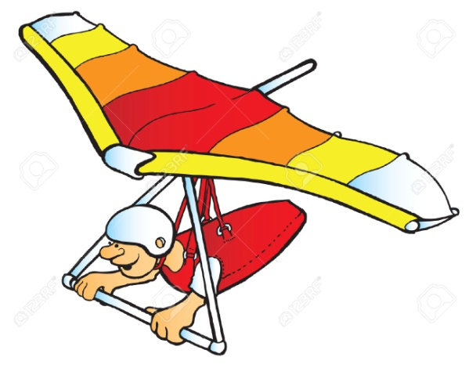

A) Rafting
B) Bungee jumping
C) Skateboarding
D) Hang gliding

2.3.4. soruları verilen paragrafa göre cevaplayınız

Different extreme sports are very popular nowadays.Air extreme sports are, for example, bungee jumping, sky diving, parachuting. My friends called me as an adrenalin seeker.The most attractive air extreme sport for me is sky diving .I think it is more exciting than other air sports .However,my brother,Sam,prefers skateboarding to sky diving.Because he thinks it’s less dangerous and challenging than sky diving.I tried sky diving on our trip with my family last summer. The scenery was fascinating! I felt myself like a bird.

2. According to the text……........................

A) The writer doesn’t prefer sky diving.
B) Scuba diving is the most exciting sport.
C) Sam is an adrenalin seeker.
D) The writer enjoyed sky diving last summer.

3. Sam ………………………………
A) would rather do easier sports.
B) has the same preferences with his brother.
C) tried sky diving last summer.
D) thinks skateboarding is the hardest sport.

4. Adrenalin seeker ………………………………..
A) is a kind of sport
B) is an equipment of parachute
C) takes part in activities involving physical risk.
D) doesn’t prefer doing extreme sports.

5. ve 6. soruyu verilen paragrafa göre cevaplayınız.
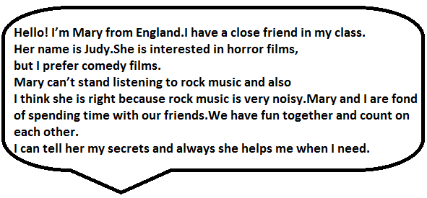
5. Verilen ifadeye göre hangi seçenek doğrudur?
A) They are fond of rock music.
B) Mary doesn’t trust Judy.
C) Mary and Judy hate meeting with their friends.
D) They have different preferences about films

6. Judy ………………………………………………
A) doesn’’t like horror films.
B) never helps Mary when she needs.
C) thinks rock music is unbearable.
D) loves staying alone.

7. Boşluğa hangi seçenek gelemez.
Beren : What’s your favourite sport?
Sema : It’s bungee jumping.
Beren : Oh!You’re crazy.It’s so dangerous.Why do you like it?
Sema : I know it is dangerous however it’s ……………………….

A) boring
B) fascinating
C) entertaining
D) exciting

8. Mr. Jonathan : Hello! Mr. Jonathan is speaking Could I speak to doctor,please?
Secretary : Hello!I’m afraid he isn’t available now.
Would you like to leave a message?
Mr. Jonathan : No,thanks ……………………………….

A) Could I take your number please?
B) I’ll call back later.
C) I’m waiting now.
D) Can you hold on a moment,please?

9. Diyalogtaki boşluğa uygun ifadeyi bulunuz.
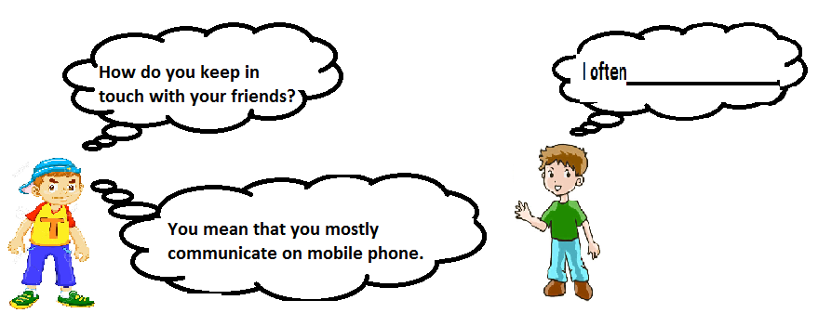
A) meet at cafe
B) write letters
C) send a fax
D) send text messages

10. Verilenlerden hangisi görselde yoktur.
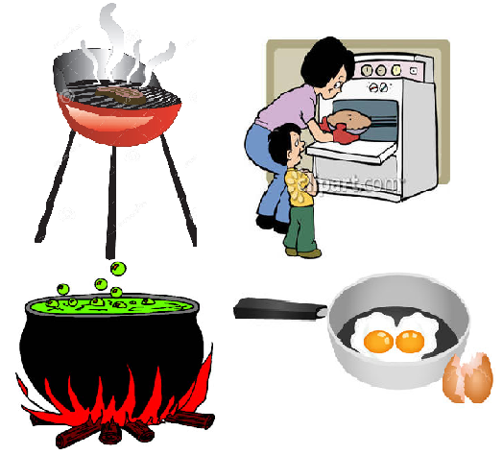
A) Steam B) Boil
C) Grill D) Bake
11. Boşluğa gelecek uygun cümleyi bulunuz.
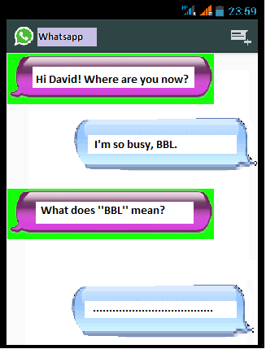
A) See you soon.
B) Be back later
C) Bye for now
D) Bring back later

12. Anlam bütünlüğünü bozan cümle hangisidir?
(I) I prefer parachute diving to mini golf.
(II) Because,it is more fascinating
(III) I would rather not do extreme sports.
(IV) I feel excited while doing it.

A) (I) B) (II)

C) (III) D) (IV)

13. Internet addicts ………………………………

A) aren’t interested in technology
B) play games on streets with friends
C) are bad at face to face communication
D) never go online

14. Which communication way do they use?

.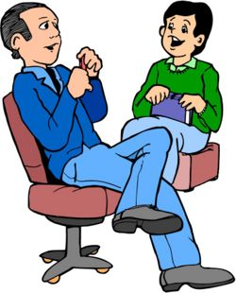

A) Face to face
B) Text message
C) Phone call
D) Social network

15.Film türleri sırasıyla hangi şıkta doğru verilmiştir.

A) Comedy-Romance-Horror-Documentary
B) Action-Romance- -Thriller- Documentary
C) Comedy-Horror-Documentary-Romance
D) Musical-Science Fiction-Horror-Action

16. Davetiyede aşağıdaki hangi sorunun cevabı yoktur?

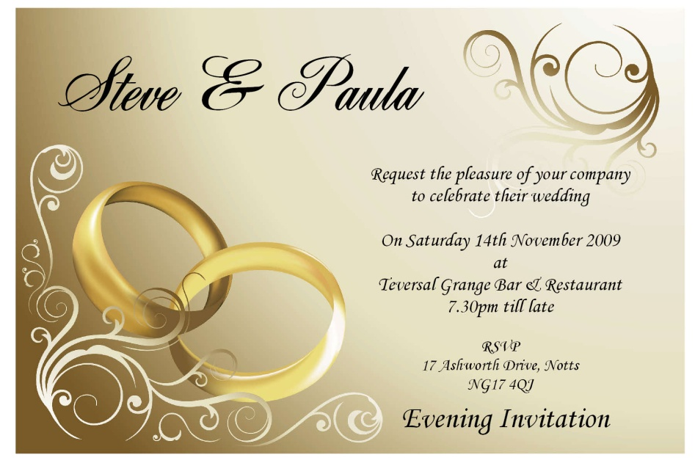

A) What is the event?
B) Who will join?
C) When is it?
D) Where is it?

17. ve 18. sorularda boşluğa uygun ifadeyi bulunuz

17. -How often do you meet with your buddies?
-…………………………… because I am very busy with my lessons.

A) Always
B) Usually
C) Often
D) Hardly ever

18. The Recipe of Old Fashioned Potato Salad

- First,boil the potatoes
- Then,peel the boiled potatoes
- Next,cut them
- After that, …………………………………………………..
- Finally,mix them and add olive oil,salt,pepper.

A) fry them on pan
B) grill the meat
C) chop green onions and parsley
D) serve it cold

19.Which following sentences about the internet is false?

A) It makes our lives easier
B) Teenagers aren’t interested in social networks.
C) We can do online shopping.
D) It makes people alone and lazier

20. Ayşe : We will try to do bungee jumping at the weekend.
Would you like to join us?
Burak : Thanks for invitation but I don’t like extreme sports.
They are very ……………… for me.

A) easy
B) entertaining
C) amuzing
D) challeging

Cevap Anahtarı
1-D
2-D
3-A
4-C
5-D
6-C
7-A
8-B
9-D
10-A
11-B
12-C
13-C
14-A
15-A
16-B
17-D
18-C
19-B
20-D

