1. Verilen tarifi doğru bir şekilde sıralayınız.
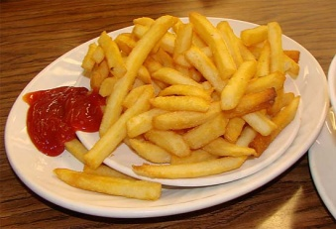
I. You can serve it.
II. Wash potatoes.
III. Add some oil and put potatoes into a frying pan.
IV. Peel and chop them.
A) II – IV – III - I B) I – III – IV - II
C) II – I – IV - III D) III – II - IV - I

2. Mark : Hello! Mark is speaking.
Secretary : Hello! How can I help you?
Mark : Could I speak to Mr. Hawking, please?
Secretary : Oh,I am afraid.He is not available now.
He went out fifteen minutes ago. ……………….
Mark : No thanks. I will call later again.
A) Hang on please.
B) Hold on a minute.
C) Would you like to leave a message?
D) Who is calling?

3. Mary : (In the kitchen) Hey John! Are you there?
John : (In the living room)Yes, What’s up?
Mary : The telephone is ringing. I am cooking now and my hands are dirty.
……………………………………………..
John : Sure. I will do it.
A) What could you do for me?
B) Could you pick up,please?
C) Where will you go tomorrow?
D) What are you doing?

4. Ali : How about having dinner out tonight?
Berk :I’d love to but my brother broke his leg while playing football,
so I have to stay with him.
Ali : …………………………….. Maybe next time.
Berk : Okay.
A) I’m sorry to hear that.
B) I hope you feel better soon.
C) It is great!
D) I’m glad to know that.<

5. ve 6. soruları aşağıda verilen görsele göre cevaplayınız.
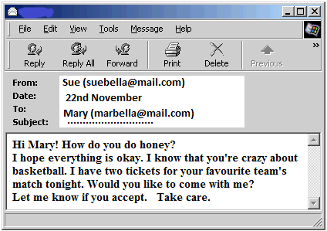
5. What is the best subject for this e-mail?
A) Giving a party.
B) Apologising to a friend.
C) Making a great offer.
D) Having a trip.
6. Who is Sue?
A) Receiver
B) Caller
C) Stranger
D) Sender
7. Which one is not about internet?
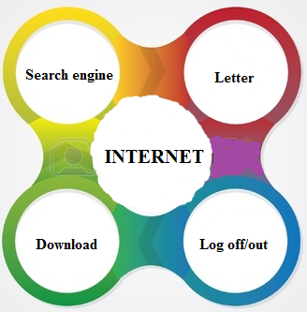
A) Letter
B) Download
C) Log off/out
D) Search engine

8. Mom : Who is your best friend?
Deniz : Sevgi.
Mom : Why?
Deniz : Because ………………………………..
Mom : You mean that you share similar likes and dislikes.
A) We have something in common.
B) She always lies to me.
C) I don’t count on her
D) She never backs me up

9. Teacher : Firstly , you should register to use gmail.
Student : Sorry, I don’t understand. What do you mean by ‘register?’
Teacher : I mean ……………………………………….
A) You should copy something from a website on internet.
B) You should connect a computer to website.
C) You should put your personel information into the website.
D) You should disconnect a computer to website.

10. Can : What do you think about parachuting?
Kerem : ………………………………………
Can : I don’t think so. To me it is very amazing.
A) It is very exciting.
B) It is boring
C) It is fantastic.
D) It is awesome.
11. Eşleştirmelerden hangisi yanlıştır?

A) 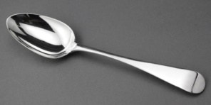 B)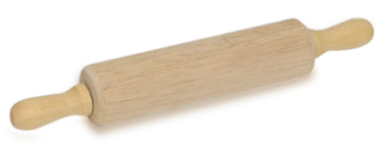
Teaspoon Rolling pin

C) 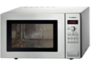 D)
Microwave Pan

2. 13 . 14. Soruları verilen konuşma balonlarına göre cevaplayınız.
I think facebook has an important role in our lives. Because we can share photos and activities with our followers or find our old friends,for example a best friend from primary school.

Jack
I think facebook has negative effects. Because people don’t need to face to face communication in real life. They become unsocial and spend too much time on internet.

Bob

12. What does Bob think about ?
A) It makes people alone.
B) Everybody has to use facebook
C) It is good for people.
D) We can’t do anything without facebook.

13. Jack ………………………………………
A) doesn’t use facebook to find friends.
B) thinks facebook is bad for people.
C) doesn’t suggest facebook.
D) thinks facebook has positive effects.

14. ‘Face to face communication’ means ………………………….
A) to send an e-mail a friend.
B) to chat on the internet with buddies.
C) to speak a real person ,having eye contact with him/her.
D) to write a letter by keyboard

15. Tabloya göre yanlış verilen ifade hangisidir?
x = never * = seldom ** = sometimes *** = usually **** = often

 | Hang out | Do exercises | Ride a horse | Listen to rock music
Sue | x | ** | * | x
Tom | ** | **** | * | *
Jerry | * | ** | *** | x
Peter | *** | ** | x | ****

A) Sue seldom rides a horse
B) Tom sometimes hangs out
C) Jerry never listens to rock music
D) Peter often does exercises.

16. Joe : Would you like to eat pizza?
Kerry : No,thanks. ………………………………
Joe : Okay I will give you some lemonade then.
A) I’m thirsty
B) I’m not full
C) I’m hungry
D) I’d like to

17. Jack : I want to buy a present for Cindy because tomorrow is her birthday.
Could you help me please?
Susan : Sure. I think ……………………………………… because she follows the fashion.
A) You shouldn’t buy anything.
B) You can buy a trendy blouse..
C) You don’t have to go to the party
D) You didn’t give her a present.

18. Soruya uygun cevabı seçiniz.
A : How often do you visit your grandparents?
B : ……………………………………………….
A) I visited them two days ago.
B) She visits them everyday.
C) I visit them twice a week.
D) I will visit them next week.

19. Boşluğa uygun olmayan ifadeyi bulunuz.
Elif : What kind of music do you listen?
Selim : I listen to rock music.
Elif : I don’t like this kind of music because I think …………………………..
A) It is very noisy
B) It is very ridiculous
C) It is unbearable.
D) It is wonderful.

20. Ali : May I use your laptop please?
Bera : …………………………………, because I have to study on my project.
A) Of course
B) I am afraid you can’t
C) Certainly
D) Absolutely

Cevap anahtarı:

1. A
2 .C
3 .B
4 .A
5 .C
6 .D
7 .A
8 .A
9 .C
10 .B
11 .D
12 .A
13 .D
14 .C
15 .D
16 .A
17 .B
18 .C
19 .D
20 .B

Functions(Kazanımlar)
1-Describing simple processes (Unit 3)
2-Handling phone conversations (Unit-4)
3-Making simple inquiries(Unit-4)
4-Expressing concern and sympathy(Unit-4)
5-Making simple inquiries(Unit-4) Accepting and refusing(Unit-1)
6-Making simple inquiries(Unit-4)
7-Making simple inquiries(Unit-5)
8-Giving explanations/reasons(Unit-1)
9-Giving explanations/reasons(Unit-5)
10-Stating personal opinions(Unit-2)
11-Naming common objects(Unit-3)
12-Stating personal opinions(Unit-2)
13-Statin
g personal opinions
14-Making simple inquiries(Unit-5)
15-Describing frequency adverbs(Unit-2)
16-Accepting and refusing(Unit-1) Making simple inquiries(Unit-3)
17-Stating personal opinions(Unit-2)

18- Describing frequency adverbs(Unit-2)
19-Expressing likes and dislikes(Unit-2)Expressing preferences(Unit-2)
20-Making simple requests(Unit-5)

