PERSONAL-EXPERIENCES - COOPERATION IN THE FAMILY RUNNING ERRANDS
Complete the sentences with “ Me, too” or “ Me,neither” as in the examples.
Eg. A: I have been to İstanbul for several times. A: Murat hasn’t finished his project yet.
B: Me,too. B: Me,neither.
1. A: I have ridden a horse . 6. A: Mert hasn’t swum in a cave yet.
B: _______________ . B: ________________ .
2. A: I haven’t seen a ghost yet. 7. A: Ayşe has seen a sunk city.
B: _______________ . B: ________________ .
3. A: I have never walked on the sea. 8. A: Emre hasn’t visited Ephesus yet.
B: _______________ . B: ________________ .
4. A: I have watched a few football matches. 9. A: Esra has seen a dog bite a man
B: _______________ . B: ________________ .
5. A: Beyza hasn’t gone snowboarding yet. 10. A: My grandpa has driven a truck.
B: _______________ . B: ________________ .
- Match the sentences with the pictures.
- 2. 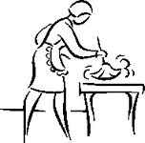 3.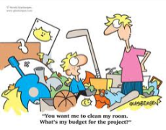 4. 5.

__________ ________ _________ ________ _________
6. 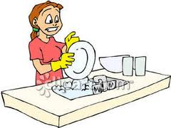 7. 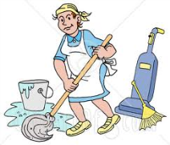 8. 9. 10.
__________ __________ _________ __________ __________
- Murat hasn’t tidied up his room yet. 6. Mrs. Merve has just done the shopping.
- Elif has just washed the dishes. 7. Mrs. Hamarat hasn’t ironed the clothes yet.
- Mrs. Hijyen has just vacuumed the floor 8. Mrs. Şirin has already dusted the furniture.
- Ayşe hasn’t done the laundry yet. 9. Edi and Büdü have already cooked the meal.
- Mr. Huysuz has already paid the bills. 10. Kamile has just set the table.

- Group the sentences .

- Write sentences with “ already “
__________________________________________________________
__________________________________________________________
__________________________________________________________
- Write sentences with “ just “
__________________________________________________________
__________________________________________________________
__________________________________________________________
__________________________________________________________
- Write sentences with “yet”
_______________________________________________________
_______________________________________________________
_______________________________________________________
Decide and write “just” – “already” or “yet”.
- We use _________ when we talk about the events that we completed a short time ago before the estimated time
- We use _________ when we talk about the events that we completed a long time ago before the estimated time.
- We use _________ when we talk about the events that we couldn’t complete before the estimated time.
Circle the correct option.
- I have already / yet finished my homework.
- Mert hasn’t decorated the party room just / yet .
- Cansu has already / yet travelled in a hot air balloon.
- Emel and Cemre have just / yet gotten up.
- We have already / yet visited the Atatürk’s moseloum .
- I haven’t seen a lion yet / already.
- Zeynep has just / yet called me and told the problem.
- Mert has just / yet crashed into the tree.
- We haven’t watered the flowers just / yet.
- Can has already / yet won the lottery.
- We have already / yet studied for the exam.
- They haven’t watched the film just / yet.

