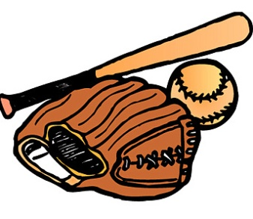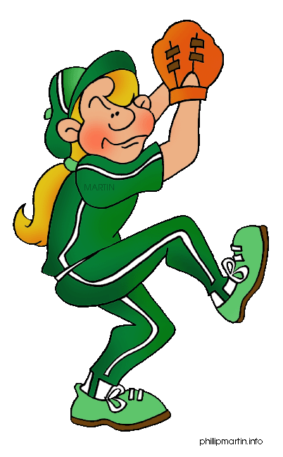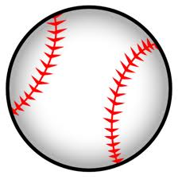

1. What you use to hit the ball with.

2. A five-sided rubber slab at one corner of a baseball diamond.

3. What many players wear on their head.

4. A player who catches the ball.

5. Shape of the baseball pitch.

6. A pitched ball that is in the strike zone.

7. The slightly elevated ground on which a baseball pitcher stands.

8. Something you can wear to protect your head.

9. The person who looks after the equipment.

10. Opposite of *infield*.

11. One of nine parts of a baseball game.

12. A place where pitchers practice throwing a ball before the game.

13. A batted ball that lands on the outside the foul lines.

14. The player who defends the area between second and third base.

15. To hit a baseball lightly so it only rolls a short distance.

16. A heavy glove worn by the catcher.

17. To dive toward a base to avoid being tagged out.

F

R

