

**Name : Class:5/__**

**Surname: Number:**

**A) Write the words under the pictures. (Kutudaki kelimeleri resimlerin altına yazın) (3x10:30p)**

**toy shop – supermarket – restaurant - school – hospital – cinema – stationery - playground – bank – police station**

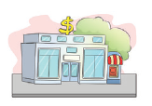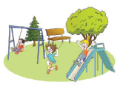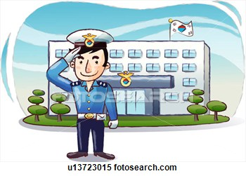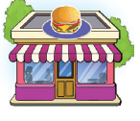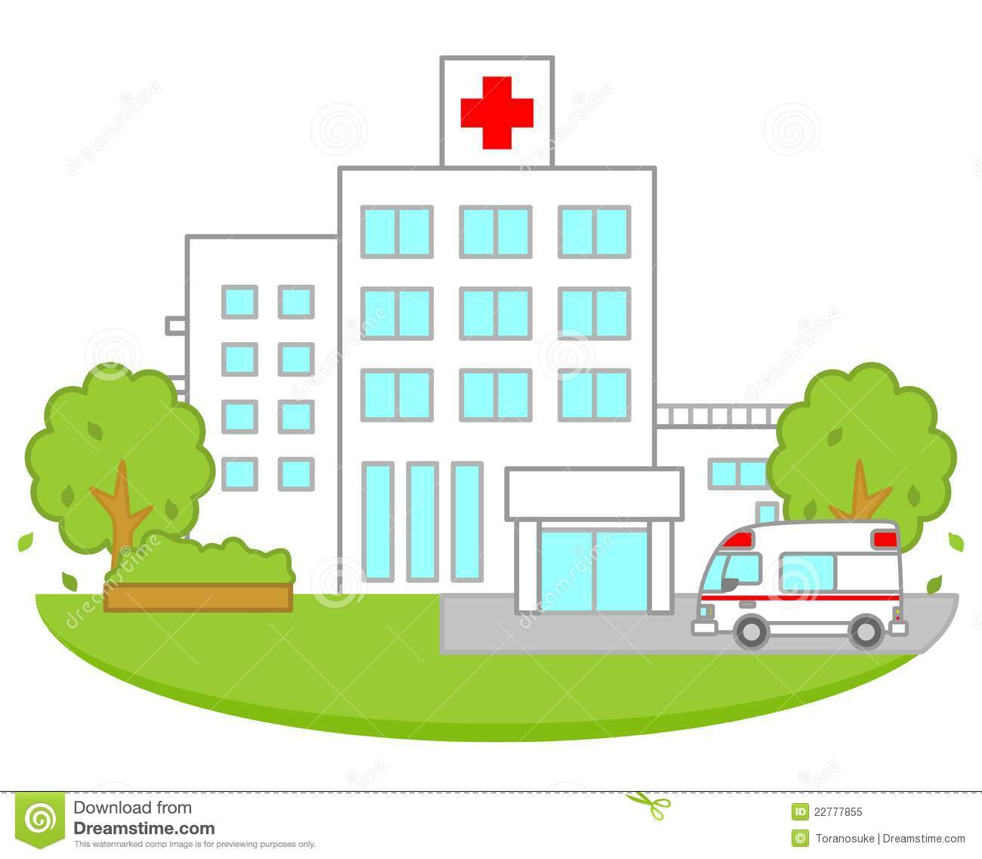

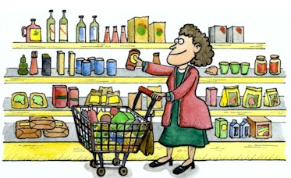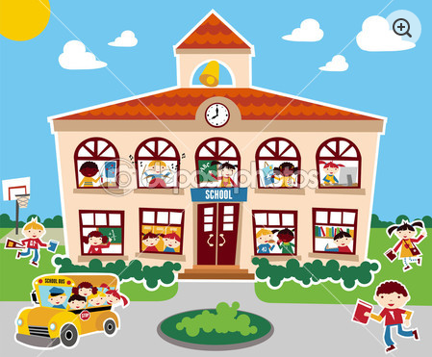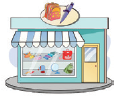

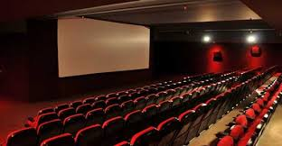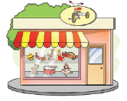

**B)Write the correct preposition under the pictures (Resimlerin altına doğru yer edatlarını yazın) (2x5=10p)**

**behind - on - between - next to - in front of**

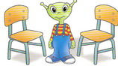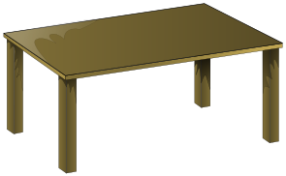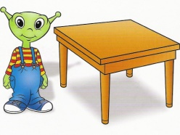



**1)................................. 2) ............................... 3)............................... 4) ............................... 5) .............................**

**C) Match the directions with the labels. (Kutudaki yön tarifleriyle tabelaları eşleştirin) (5x4=20p)**

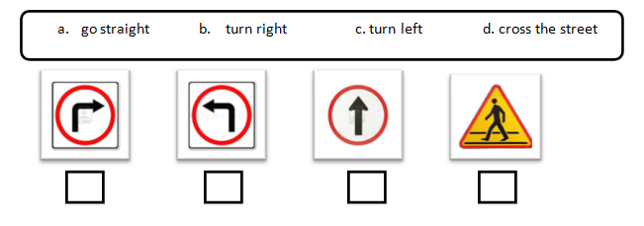

**D) Circle the best option. (Doğru seçeneği yuvarlak içine alın) (4x10=40p)**

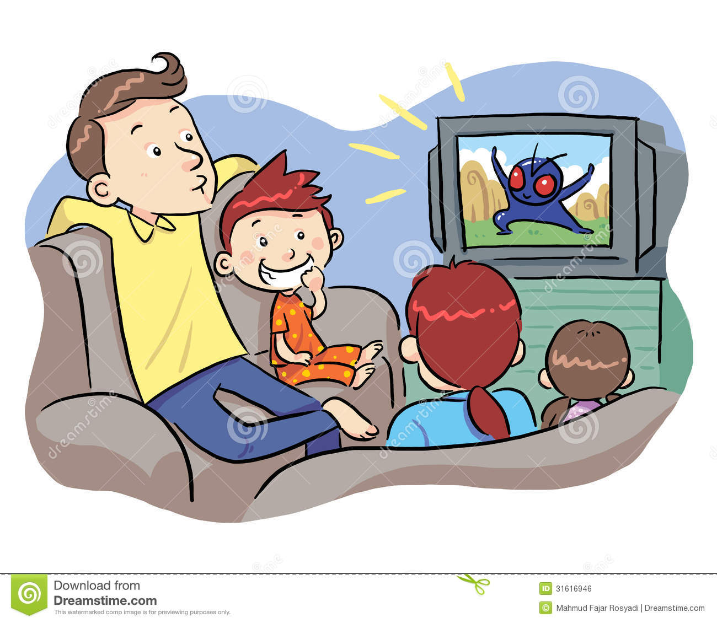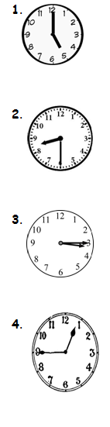

**1**. **a)** It is five o’clock **7.** **Yandaki aktivitenin İngilizcesi nedir?**

**b)** It is quarter to nine. a) catch the school bus

**c)** It is quarter past one. b) watch TV

**d)** It is half past two. c) have lunch

d) classes start

**a)** It is quarter to four ***8.ve 9.soruyu resme göre işaretleyiniz***

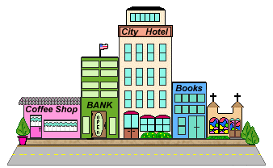**b)** It is half past eight

**c)** It is quarter past six.

**d)** It is eleven o’clock.

**a)** It is half past seven.

**b)** It is half past ten .

**c)** It is quarter past three.

**d)** It is eight o’clock.

**8.** The coffee shop is______ the bank

a) between b) next to

**a)** It is five o’clock. b) in front of d) behind

**b)** It is three o’clock.

**c)** It is half past twelve. **9.** The bank is ________ the coffee shop

**d)** It is quarter to one. and city hotel

a) between b) opposite

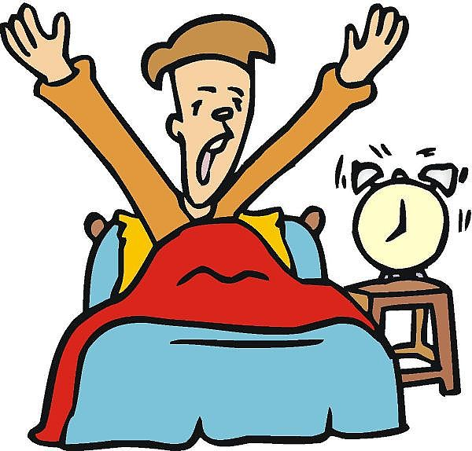**5. Yandaki görselin İngilizcesi nedir?** c)behind d) in front of

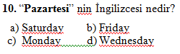 a) have breakfast b) get up

c) watch TV d) brush teeth

**6. Aşağıdaki sayılardan hangisi DOĞRUDUR?** a) two: 2 b) six: 3 c) five: 12 d) ten: 20