START

teach 

hear 

shake

give 



hide

steal 

hang 

say 

build 

drive 

sleep 

spin 

ride 

make 

bend 

come 

feel 

bite 

forget 

write 

break 

spill 

wake 

sweep 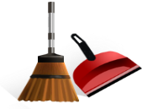

become 

fight 

grow

feed 

sting 

stand 

bring 

sell 

pay 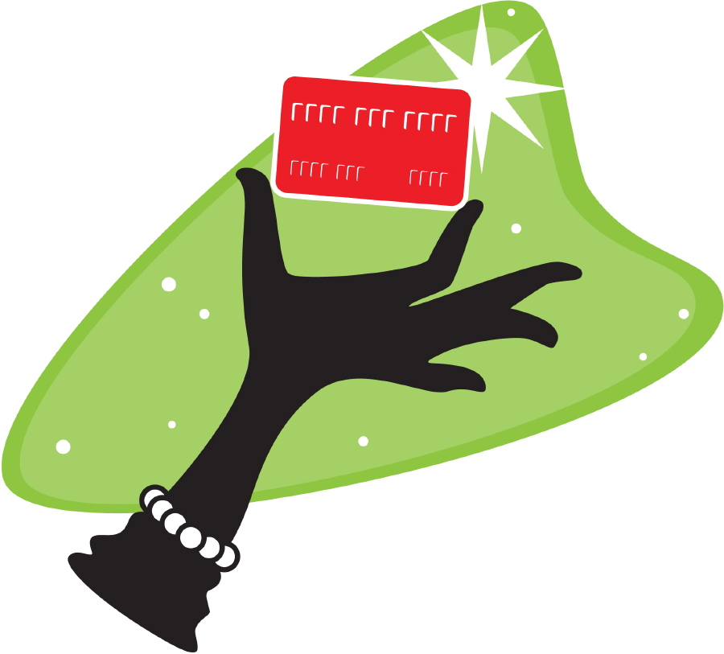

send 

read

sing 

hold 

lose 

have 

go 

fly 

tell 

keep 

catch 

blow

think 

swim 

stink 

know

do 

wear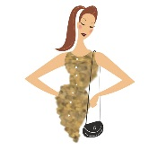

see 

spend

run 

rise 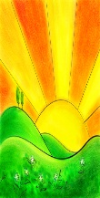

speak

ring 

leave

get

find 

END