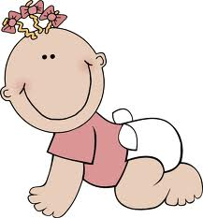

-

-

1. Your mother’s son.

2. Your father’s daughter.

3. Your father’s brother.

4. Your father’s sister.

5. Your father’s parents.

6. The children of your aunt and uncle.

7. Your aunt’s and uncle’s son is your parents …..?

8. The daughter of your aunt’s and uncle’s.

9. A married woman.

10. Opposite of wife.

11. A son or daughter.

12. A son of your grandparents’ son.

13. Your mother and father.

14. Another word for mother.

15. The father of one’s husband or wife.

16. Another word for father.

17. The mother of one’s husband or wife.

18. If a husband and wife have a boy and a girl, they have ……..

-

-