

**Board Game**

What are some reasons you might steal?

Why would animals become extinct?

What will happen if you break the law in this country?

When should a person get married?

**Roll the dice and go back those spaces**

What might happen if you tell a lie?

Where would you go on your dream vacation?

What job would you do if money were no object?

**Go back 3 spaces**

Why might a person gain too much weight?

What could you ask someone if you are lost?

What should you do to stay healthy?

What would you do first if you won the lottery?

When may you get your driver’s licence in the US?

What will happen if you run or jump on wet floors?

**Switch places with your partner**

What would you do if the fire alarm rang?

Why would someone want to go to college?

Why should you listen to your parents?

What will you do when you learn English?

**Move ahead 3 spaces**

What can a child do that you can’t?

What might you do if it is raining?

**Lose your turn.**

When should you have your oil changed (in your car)?

What would you like to eat right now?

What is something you could do but now you can’t?

**Mixed Modals**







**Start**

Why should you go to the dentist every year?

Why should people be concerned about the environment?

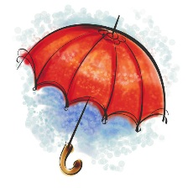

Do you think people should be allowed to smoke anywhere?

**The End**

What might happen if you have an allergy to something?

What would a parent do if their child is hungry?

What should you do if you smell smoke?

What can people do that animals can’t?

Why might a person say “God bless you!”?

What should you do if you see someone choking?