Lesson Plan / Study Plan:
- Talk about the different places students have gone to. (Write all the names of the countries visited on the board).
- Handout #1: Have students fill in the chart with the names of the countries + add extra countries that aren’t represented.
- Then ask the students what language is spoken in the different countries and add it to the worksheet.
- Now it is interesting to find out what people are if they come from for instance Norway. Then they are Norwegian and that word goes into the chart as well.
- Handout # 2: Where does the car come from? Students identify the origins of the cars by looking at the stickers.
- Handout #3: Find out how many students have been to different places. Cross out a face for each person that has been to a specific country.
- Handout #4: Crossword (Flags)
DK
NL
CH
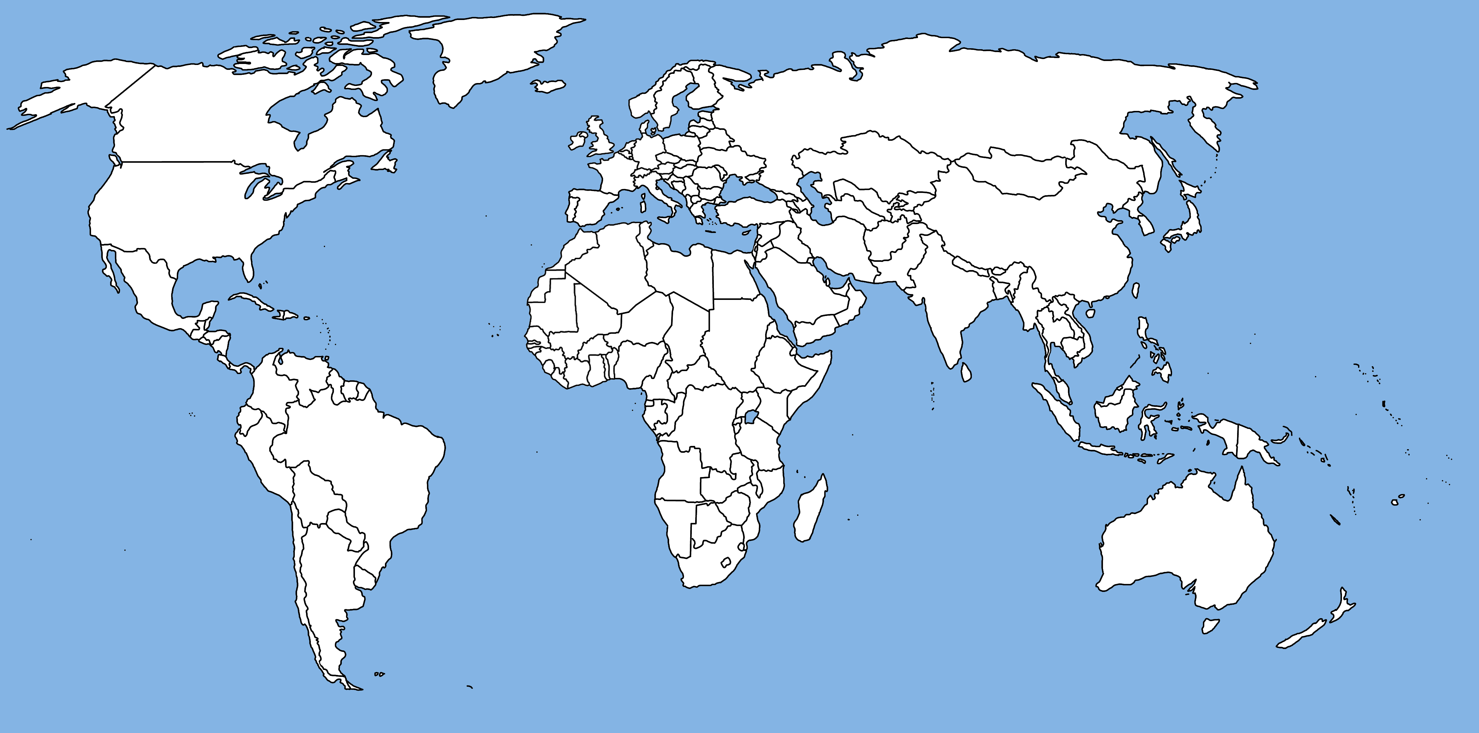

S
PL
USA
GB
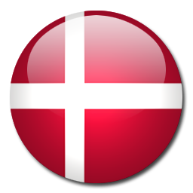

COUNTRY  WS #1 | NATIONALITY | LANGUAGE

E
USA
WS #2

SF
CND

I

PL

F
P

BG

GB

GR
N

S
NL

D
A

AUS

CH

HUN

LI

CH

NZ

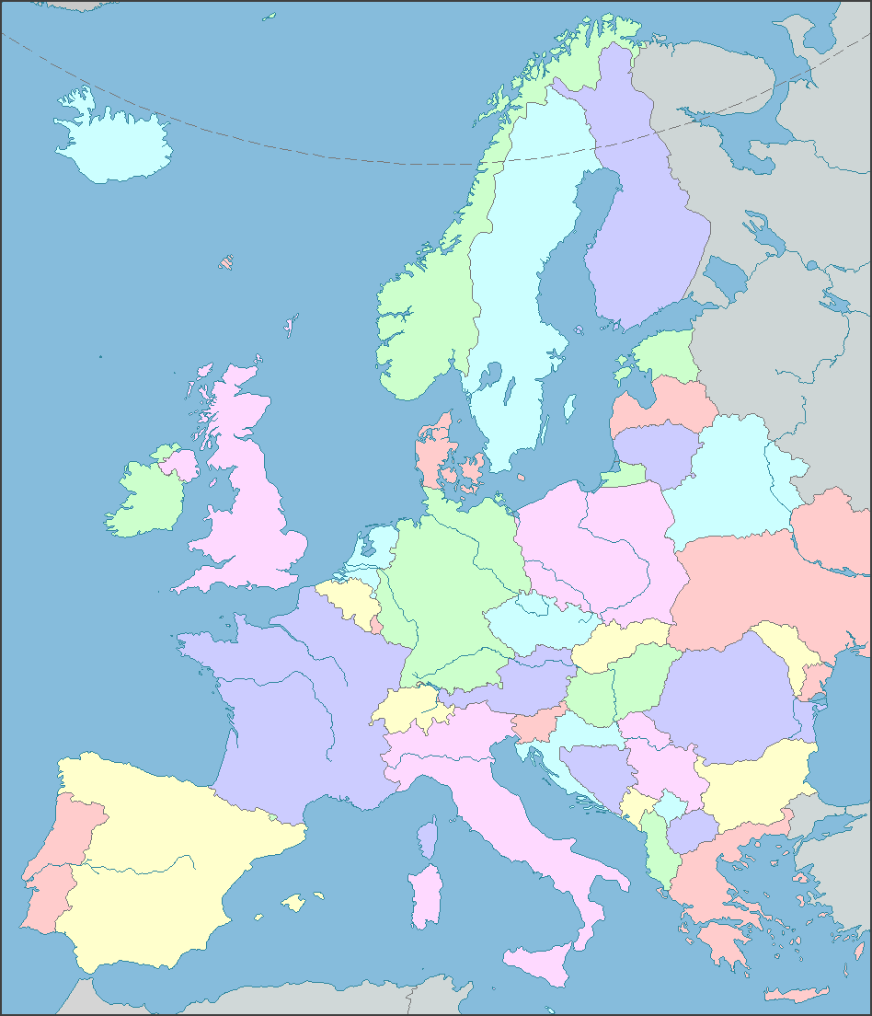
WS #3

Where have you been?
Find out how many people have been to the different countries or continents. Cross out a face for each person that has been there.
Ask:- Have you been to………….? Or –Where have you been?

WS #4

