|  |  |  |  |  |  |  |  |  |  |  |  |
| --- | --- | --- | --- | --- | --- | --- | --- | --- | --- | --- | --- |
|  |  |  | 2 |  |  | 3 |  |  |  |  |  |
|  | 1 |  |  |  |  |  |  |  |  |  |  |
|  |  |  |  |  |  |  |  |  |  |  |  |
|  |  |  |  |  |  | 5 |  |  |  |  |  |
|  |  |  |  |  |  |  |  |  |  |  |  |
| 4 |  |  |  |  | 6 |  |  | 7 |  |  | 12 |
|  |  |  |  |  |  |  |  |  |  |  |  |
|  | 8 |  |  |  |  |  |  |  |  |  |  |
|  |  |  |  |  |  |  | 9 |  |  |  |  |
|  |  | 10 |  |  |  |  |  |  |  |  |  |
|  |  |  |  |  |  |  | 11 |  |  |  |  |
|  |

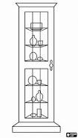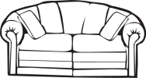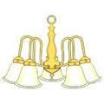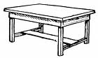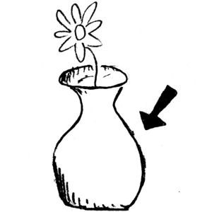5 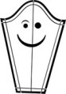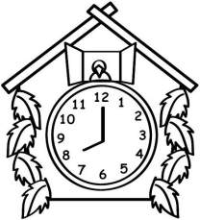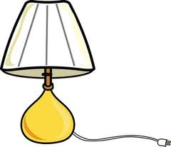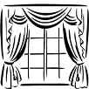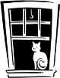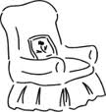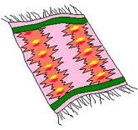 7 6↓ 10 6→

7

4

111

12 11

3

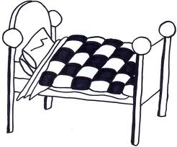 8

2 9

1. гардероб
2. кресло
3. кровать
4. окно
5. ваза
6. сервант
7. люстра
8. ковёр
9. шторы
10. диван
11. лампа
12. часы