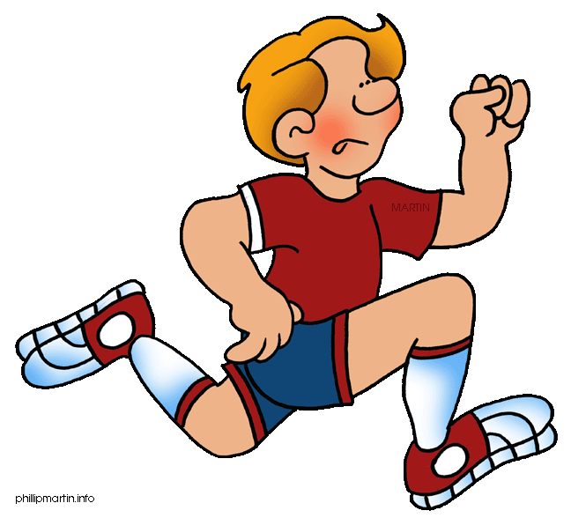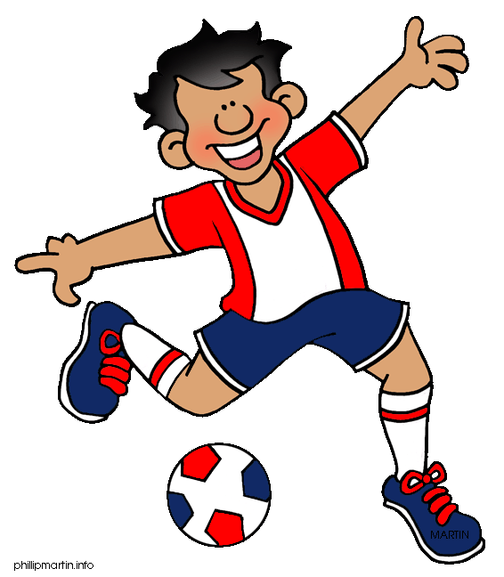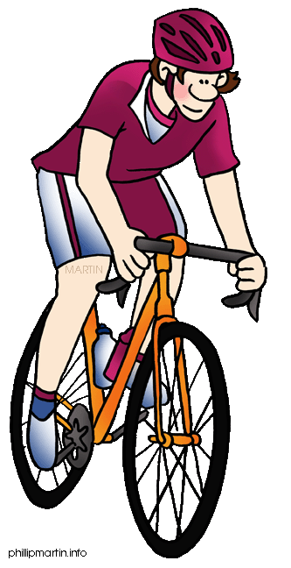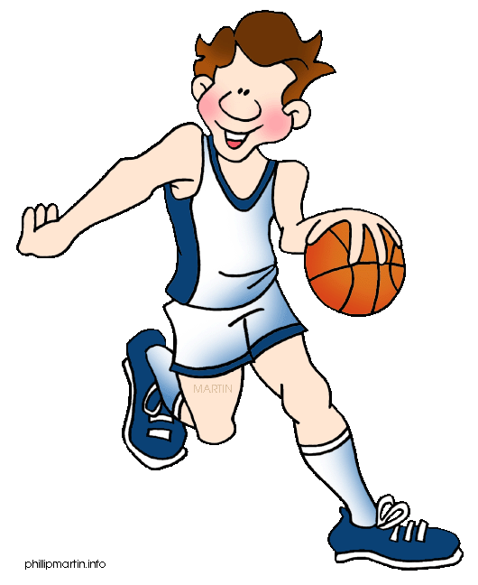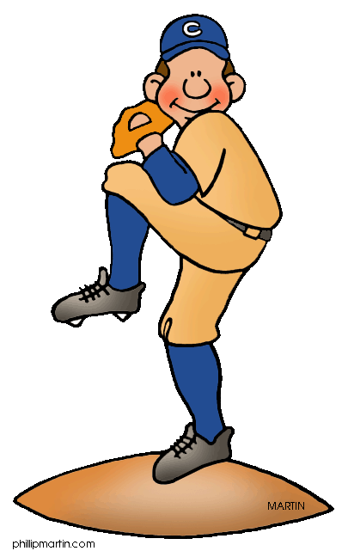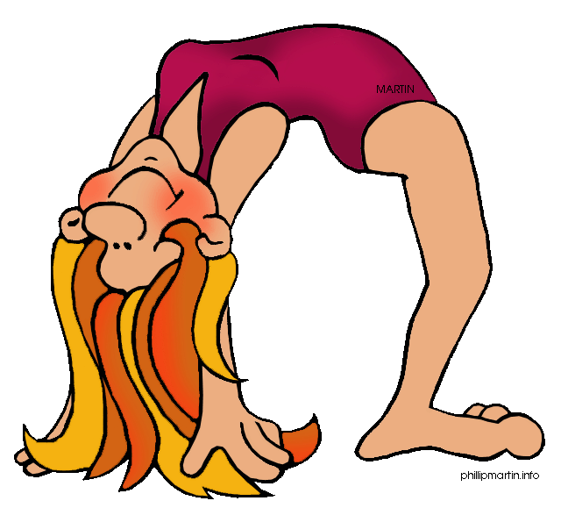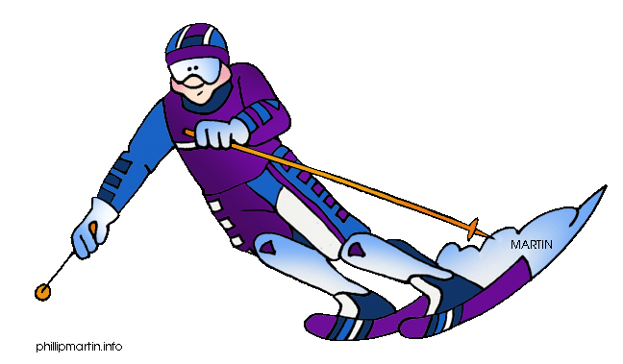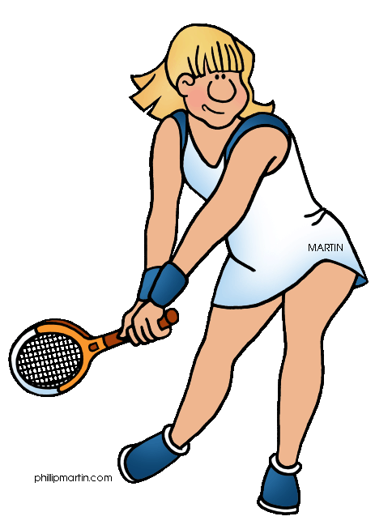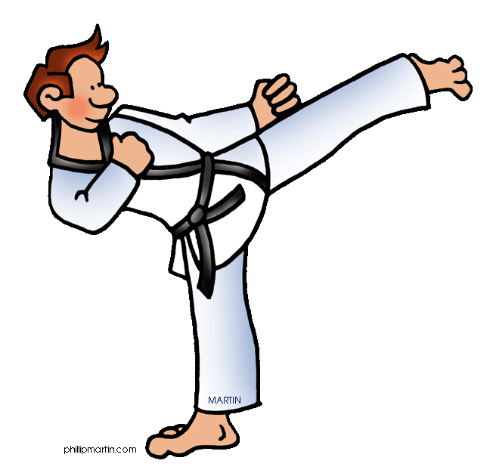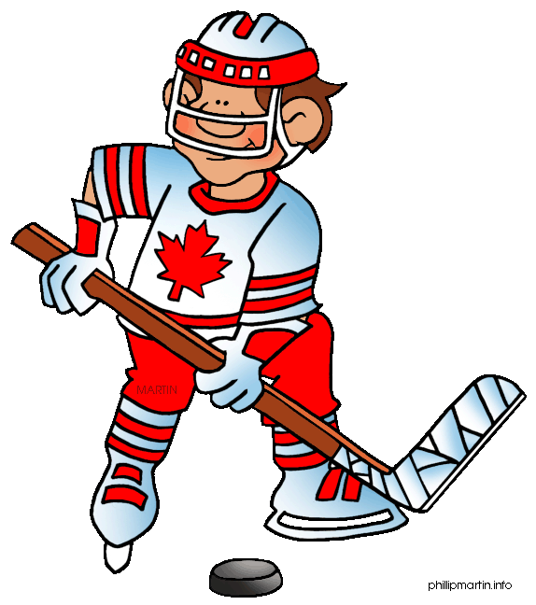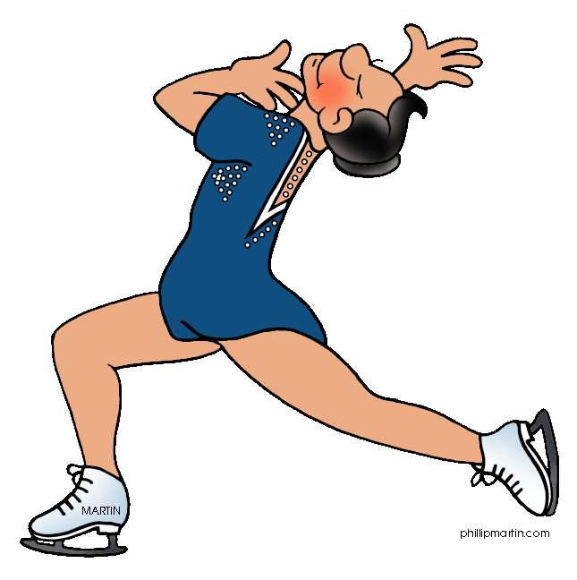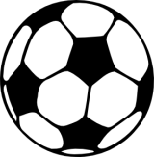

How long is each half of a soccer game?

What sport is a lot like softball?

Name two individual sports and two team sports.

What are the medals called the first, second and third places are awarded?

What does NBA mean?

Name two sports played/done in water.

How many players start for each team in soccer?

What do the rings of the Olympic flag represent?

What do you call a player whose position is in the goal?

How many players has a basketball team?

Name two extreme sports.

Stand on one leg for 30 seconds.

In which sport do you use a bat?

What do you call a person who carries a golfer’s bag of clubs?

Which sport uses a net, a racket, and a shuttlecock?

How often do the Summer Olympic Games take place?

What is the most popular sport in the world?

What sport did Michael Jordan play?

What do you call the person who makes sure the rules in a game are not broken?

You get an extra throw!

Name a sport that doesn’t use a ball!

What color cards can a player be shown?