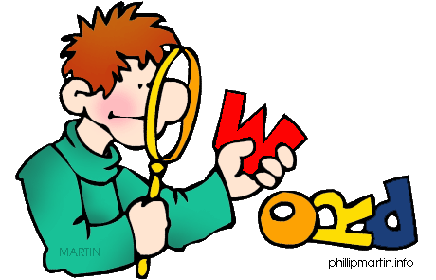

|  |  |  |  |  |
| --- | --- | --- | --- | --- |
| **1** | **was** | **broke** | **drink** | **fought** |
| **2** | **forgot** | **give** | **hit** | **cut** |
| **3** | **dreamt** | **ate** | **built** | **build** |
| **4** | **paid** | **laid** | **send** | **sank** |
| **5** | **read** | **lost** | **wrote** | **ring** |
| **6** | **write** | **threw** | **stole** | **spoke** |
| **7** | **sat** | **told** | **is** | **borrowed** |
| **8** | **stood** | **talked** | **know** | **looked** |
| **9** | **taught** | **held** | **phoned** | **sleep** |
| **10** | **sang** | **shook** | **shot** | **hide** |
| **11** | **know** | **grow** | **shake** | **loved** |
| **12** | **were** | **preferred** | **hit** | **speak** |

You see four words in each line. One word doesn’t go with the rest because it is **not in the past**. You have to spot the odd one and highlight it.

Had – knew – shoot – went: (Shoot is the odd one; it is in the present tense)

E

**ENGLISH** Y7 Intermediate