What is a New York Minute?

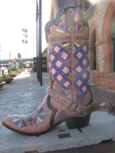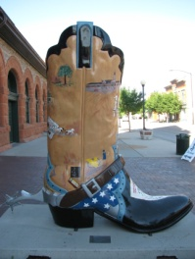

Clues:

1. Number of states in the USA.
2. State number forty-nine.
3. Capital city of Texas.
4. What is yellow and a popular means of transportation of students in the USA.
5. A famous waterfall.
6. Ocean west of the USA.
7. Color of the house where the American president lives.
8. Capital city of Wyoming.
9. Also known as the Mormon state.
10. Which state is known as *The Empire* *State* state?
11. Indigenous people of America.
12. A famous expedition team: _______ & Clark.
13. A tent made of animal skins and wooden poles.
14. A big animal that once roamed the grasslands of America.
15. Famous Apache chief.
16. What is a saguaro?
17. Famous place in Arizona. Grand ___.
18. A famous national park in Utah.
19. What is San Diego famous for? It’s _____.
20. What you can do in winter on frozen lakes.
21. Big shopping center. _____ of America.
22. Favorite food of Americans.
23. State which is abbreviated MT.
24. This thing sometimes causes days off from school.
25. Abbreviation for National Basketball Association.

What is a New York Minute?



A

W

O

S

A

N

A

T

M

K

A

E

B

L

E

L

A

T

A

O

E

C

B

S

U

T

C

C

O

M

I

N

O

G

N

O

B

I

P

T

W

H

I

E

Clues:

1. Number of states in the USA.
2. State number forty-nine.
3. Capital city of Texas.
4. What is yellow and a popular means of transportation of students in the USA.
5. A famous waterfall.
6. Ocean west of the USA.
7. Color of the house where the American president lives.
8. Capital city of Wyoming.
9. Also known as the Mormon state.
10. Which state is known as *The Empire* *State* state?
11. Indigenous people of America.
12. A famous expedition team: _______ & Clark.
13. A tent made of animal skins and wooden poles.
14. A big animal that once roamed the grasslands of America.
15. Famous Apache chief.
16. What is a saguaro?
17. Famous place in Arizona. Grand ___.
18. A famous national park in Utah.
19. What is San Diego famous for? It’s _____.
20. What you can do in winter on frozen lakes.
21. Big shopping center. _____ of America.
22. Favorite food of Americans.
23. State which is abbreviated MT.
24. This thing sometimes causes days off from school.
25. Abbreviation for National Basketball Association.

S

I

W

S

N

A

I

K

R

O

Y<

N

O

I

H

A

U

E

D

C

I

F

I

C

A

R

A

G

A

I

P

B

U

N

L

S

N

I

T

S

A

Y

T

F

S

E

Z

R

E

F

C

C

N

A

K

N

E

H

Y

N

O

Y

A

S

A

L

T

N

A

T

S

N

I

N

A

S

I

E

T

U

N

I

M

K

R

O

Y

W

E

N

A