WORKSHEET FOR “ USED TO “ and “ DIDN’T USE TO “
B. Fill in the blanks with “used to “ or “ didn’t use to “
1.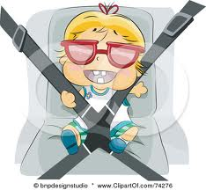 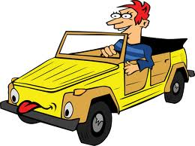
I ________________ drive a car when I was a child , but now I drive a car.
- 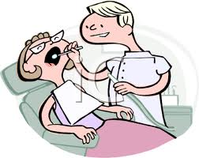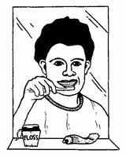
I _________________ bush my teeth when I was a child , but now I brush my teeth.
- 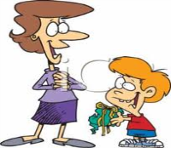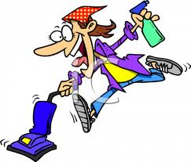
I ______________ help my mother with the housework when I was a child, but now I don’t.
- 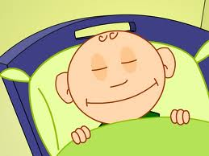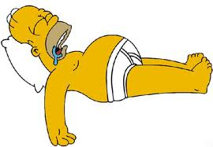
I _________________ go bed early when I a child, but now I go to bed late .
- 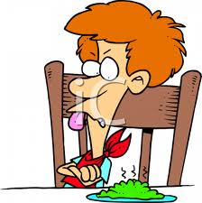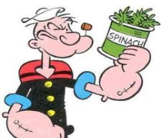
I _________________ eat spinach when I was a child, but now I eat it.
- 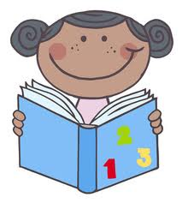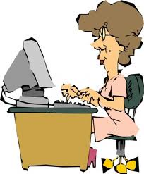
I _________________ read a book when I was a child, but now I use it .
- 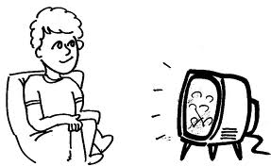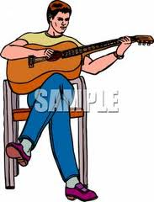
I _________________ watch Tv when I was a child, but now I play .

- Circle the correct answer “ a ” or “ b “
- When I was a child 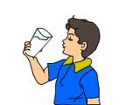 . but now 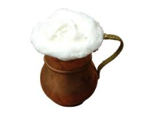,
a) I used to drink milk a) I drink ayran .
b) I didn’t use to drink milk b) I don’t drink ayran .
2. When I was a child 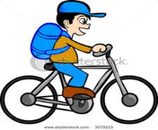, but now 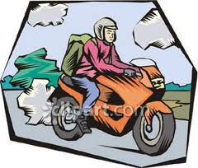,
a) I used to ride a bicycle a) I ride a motorbike .
b) I didn’t use to ride a bicycle b) I don’t ride a motorbike .
3. When I was a child 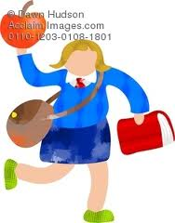, but now 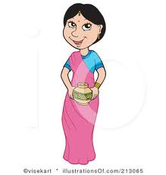,
a) I used to wear a school uniform a) I wear a school uniform
b) I didn’t use to wear a school uniform d) I don’t wear a school uniform
4. When I was a child 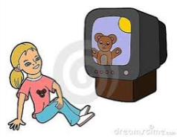 , But now 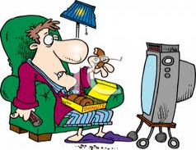,
a) I used to watch cartoons a) I watch the news
b) I didn’t use to watch cartoons b) I don’t watch the news
5. When I was a child 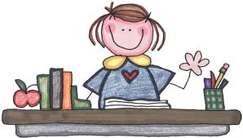, but now, 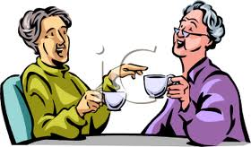
a) I used to drink tea a) I drink tea
b) I didn’t use to drink tea b) I don’t drink tea

