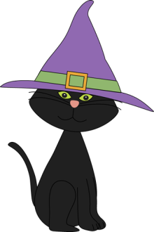
Write the words from the list in the right boxes according to their meaning

bang
bolt
smack
hit
hasten
appear
arrive
hand over
grant
perceive
deliver
go on foot
chitchat
show up
scorch
holler
traverse
listen
march
yell
pick up
roar
babble
chatter

to run
to sell
to beat
to like

to give
to come
to mean
to dream

to hear
to walk
to talk
to look

to gossip
to shout
to begin
to love

initiate - fancy – be up in clouds - desire – cherish - prefer – be moonstruck – fantasize - advertise – commerce - barter – put up for sale – express – crazy about - suggest – indicate – glance – babble – say - communicate - gaze – peek – admire – bring about

Key:
To like: fancy – desire - prefer
To beat: bang – hit – smack
To sell: barter – put up for sale – advertise
To run: bolt – hasten – scorch
To dream: fantasize – be up in clouds – be moonstruck
To give: grant – deliver – hand over
To mean: suggest – express – indicate
To come: appear – arrive – show up
To look: glance – gaze – peek
To walk: traverse – go on foot march
To talk: babble – communicate – say
To hear: listen – pick up – perceive
To love: crazy about – admire – cherish
To shout: yell – holler – roar
To begin: commerce – initiate – bring about
To gossip: babble – chatter - chitchat

