10TH GRADE AUTUMN TERM 1ST QUIZ
www.eegitimim.com
- Answer the questions below.

- What is your name? __________________________________

- How old are you? __________________________________

- Where are you from? __________________________________

- Where do you study? __________________________________

- Do you have any sisters or brothers? __________________________________

- Write questions for the answers.

- A: ________________________________?
B: My sister studies at Çanakkale 18th March University.

- A: _______________________________?
B: My brother’s name is Kemal.

- A: _______________________________?
B: My favorite movie is “Godfather”.

- A: _______________________________?
B: I like listening rock music.

- A: Why ___________________________?
B: I like reading criminal books, because they are logical. <
- Write the names of subjects below.

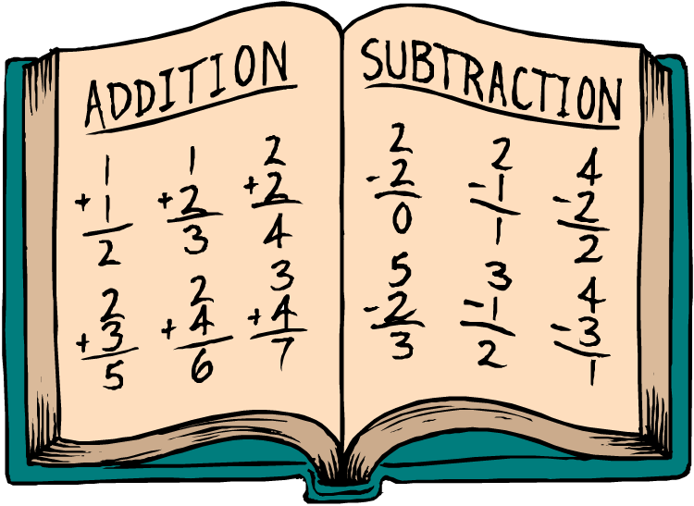

_______________ ______________ ________________ ________________
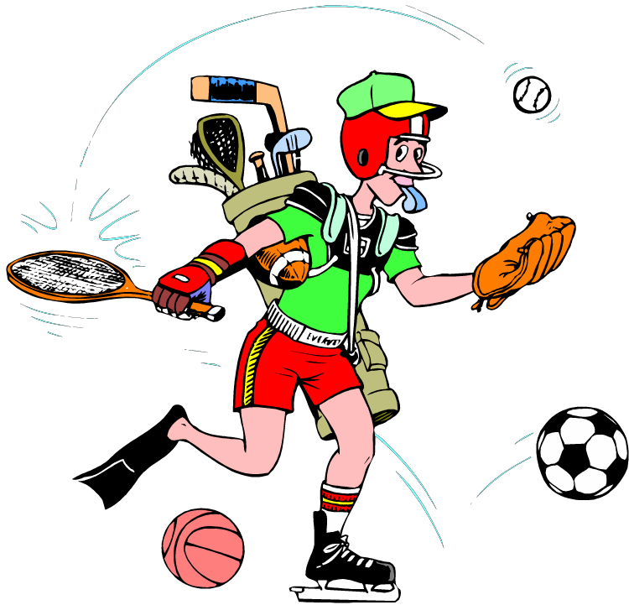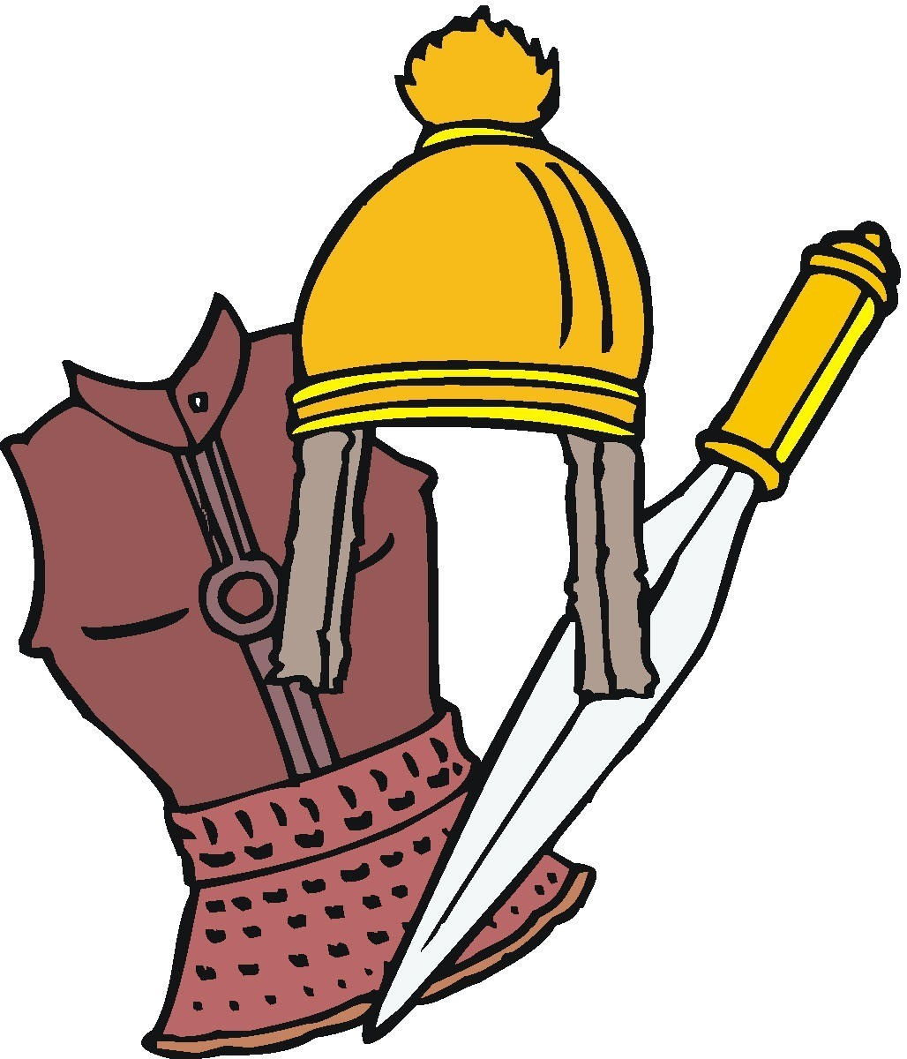

_________________ _________________ __________________ ___________________
- Read the sentences and fill the blanks with the correct word given below.

timetable - textbook - bulletin board - originally - campus - typical - welcoming - opportunity - share - culture

- I buy Biskrem from canteen, but I never _____________ it with my friends.

- Turkish ____________ is very colorful and our foods are always delicious.

- I check my school ______________ everyday to learn my school subjects.

- I am _______________ from Çanakkale, but I live in Nizip now.

- The teacher said “Everyone, open your ______________, page twenty-four.”

- There are a lot of trees and cafes in Gaziantep University _____________.

- I visit Bulgaria once a month. Bulgarian people are really _____________, they always smile at each other and say hello.

- He is a __________________ manager with his angry face and bossy behaviors.

- A notice in the _______________ says there is theatre course on Saturdays.

- She has an ________________ to go to the college. I hope she doesn’t miss it.

- What are they doing? Look at the picture and answer.
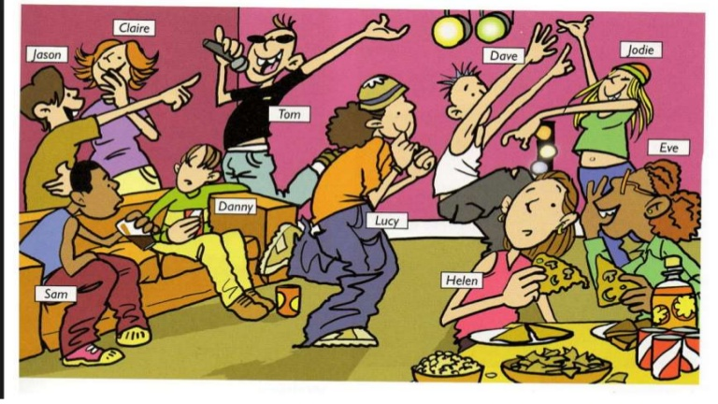
You
- What is Lucy doing? __________________________________
- What are Helen and Eve doing? __________________________________
- What are Jason and Claire doing? __________________________________
- What is Sam doing? __________________________________
- What are you doing? __________________________________

- Fill the blanks with the correct for of “will” or “be going to”.

- Craig: Hey Mark! What _______ you _______ [do] during half term?
- Mark: You _____________ [believe] it, but I ____________ __ [visit] Switzerland.
- Craig: Really? That’s great. Switzerland is great. I’m sure you ______________ [love] it.
- Mark: I think so, too. My parents and I _____________ [stay] at a hotel near the Swiss Alps.
Craig: Wow!
- Sansa: ______ we _______________ [meet] tomorrow?
Arya: Of course! At 11 am at Eskici Cafe.
- Read the text and choose the correct answer.
Martha:...What a horrible weather today. I'd love to go out, but I think it will continue raining.
Jane: Oh, I don't know. Maybe the sun will come out later this afternoon.
Martha: I hope you're right. Listen, I am going to have a party this Saturday. Would you like to come?
Jane: Oh, I'd love to come. Thank you for inviting me. Who is going to come to the party?
Martha: Well, I don’t know. But, Peter and Mark are going to help out with the cooking!
Jane: Hey, I will help, too!
Martha: Would you? That would be great!
Jane: I am going to make lasagna!
Martha: That sounds delicious!
1) What do they think about the weather? 2) What does Martha have to share?
- It's beautiful. a) News that she’s going to get married.
- It's terrible. b) News that she’s going to have a party.
- It's snowing. c) News that she’s going to have a baby.

3) What are Peter and Mark going to do? 4) What does Jane offer to do?
a) They are going to cook lasagna. a) She says she will help cook.
b) They are going to help with the cooking. b) She says she will wear a party hat.
c) They are going to wear clown dress. c) She says she will speak Italian.

